Chapter 1. An Introduction to Python Programming

Application (App) – a computer software that performs a task or a set of related tasks. It is also referred as program though an application may consist of many programs.

Types of application that can be created in Python:

* Console
* GUI
* Web
* (Scripting programs)

How Python Compiles and Runs Source Code

Source Code – the code. It has a file extension of ‘.py’.

Python Interpreter – used to translate source code into bytecode.

* The bytecode can be run on any machine with the Python Virtual Machine which is a part of the Python Interpreter.
* Python is platform-independent.

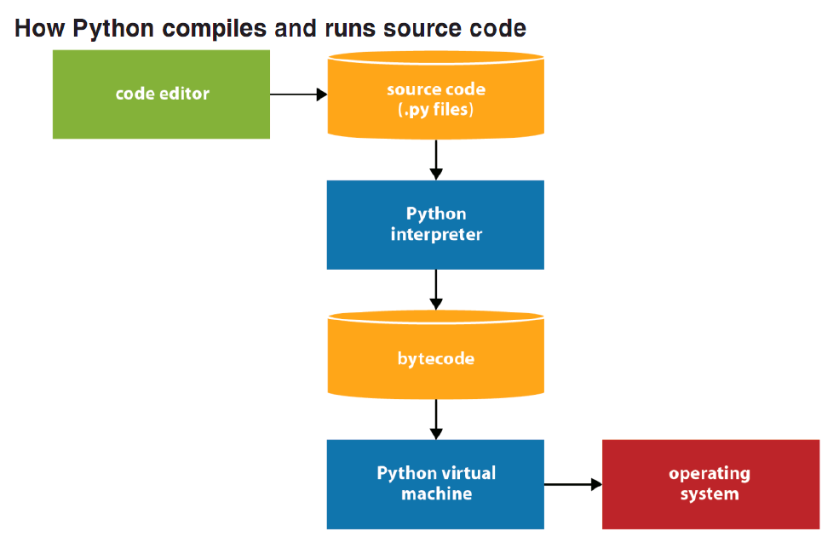

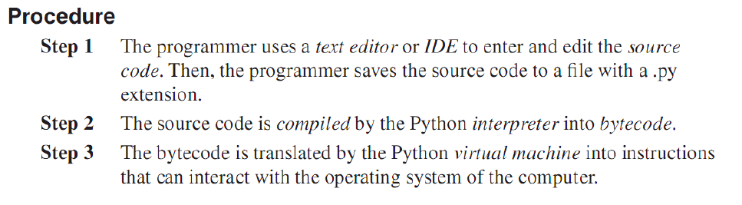

* If the program imports modules, the Python interpreter saves the compiled bytecode for those modules in files that have .pyc or .pyo extensions.
* This is an import optimization that can improve startup time for a program.

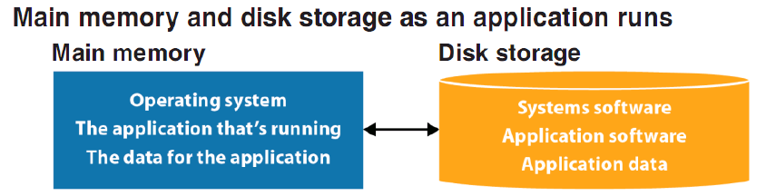

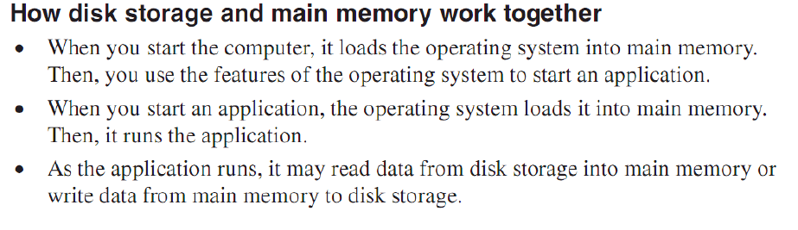

INTERACTIVE SHELL

* At this prompt, type a command and run it.
* Variable names are case sensitive.

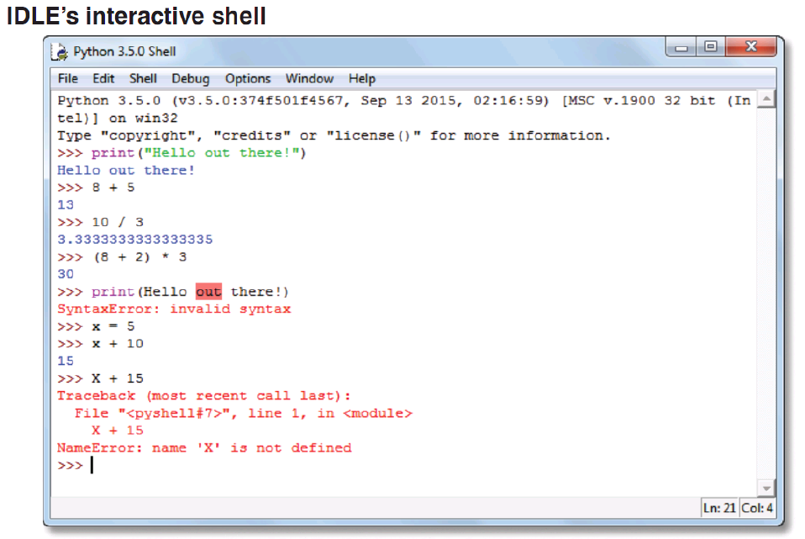

IDLE EDITOR

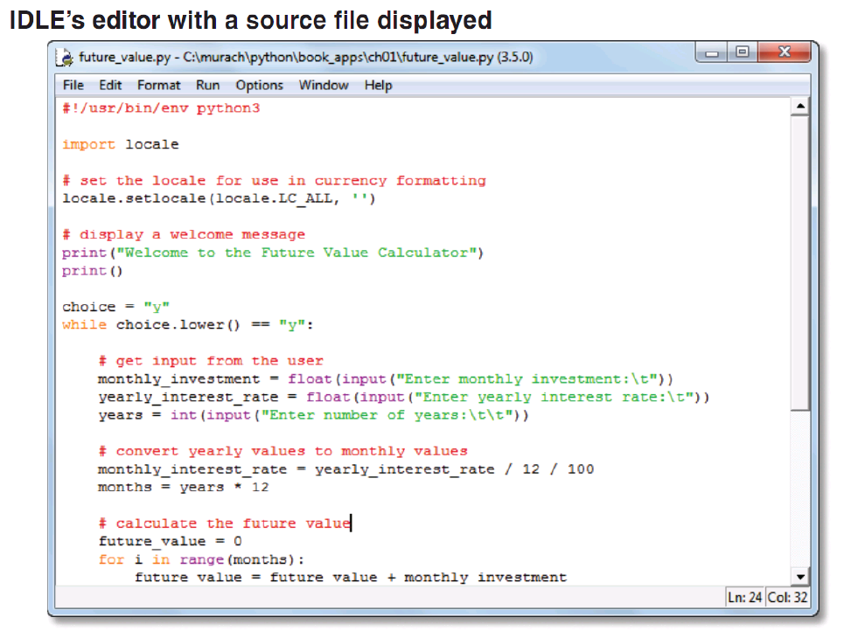

* To compile and run a program, press F5.

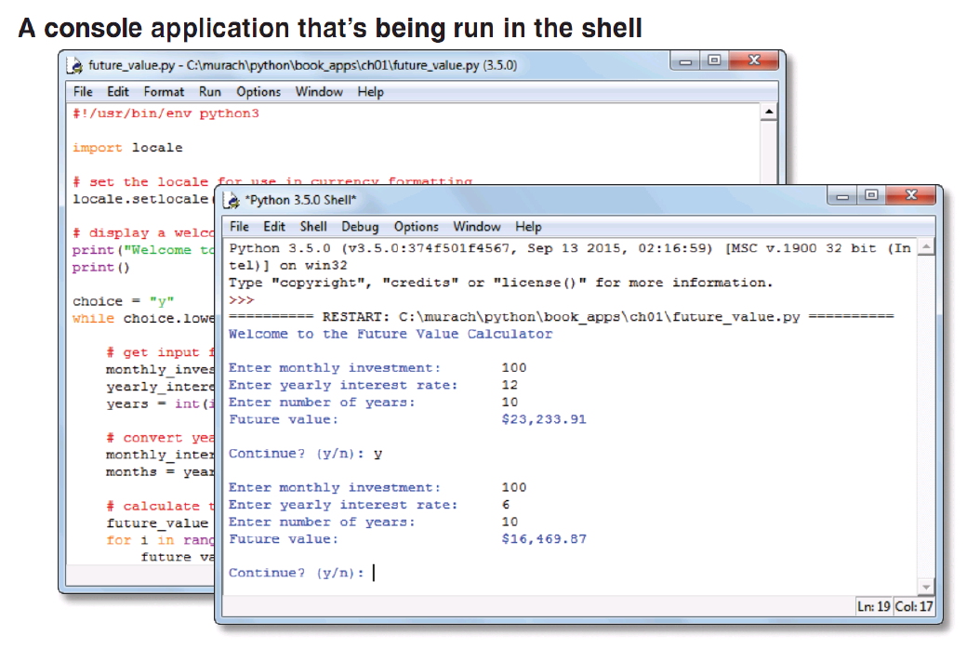

ERRORS

* Syntax error – coding rules are violated.
* Runtime error (Exception) – this error occurs after all the code is compiled cleanly and the program is executed. The program ends or crashes when it existed unless handled.

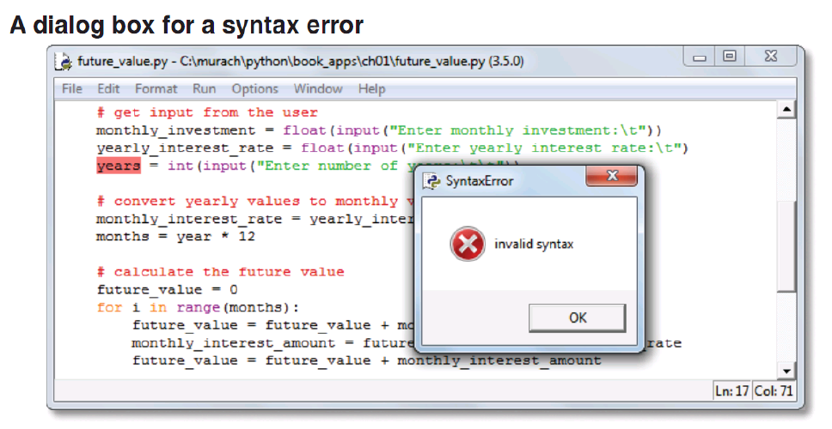

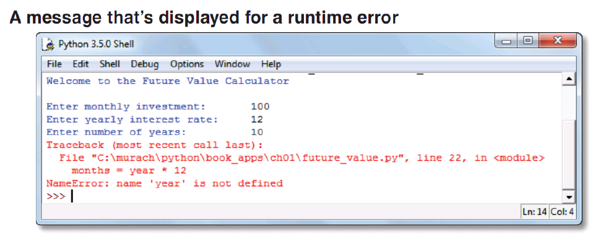

Chapter 2. How to Write Your First Programs

Statement – performs a task.

NOTE: Applicable only in the editor view and not on the interactive prompt.

* Indentation in Python is important unlike other programming languages.
* In Python, indentation is typically 4 spaces.
* To divide a long statement into multiple lines, use *implicit continuation*.
* NOTE: Divide after or before an operator, after an opening parenthesis.
* Indent continuation lines.
* You can also divide using *explicit continuation*. Use a backslash ‘\’ to show that a line is continued.
* NOTE: explicit continuation is not recommended.

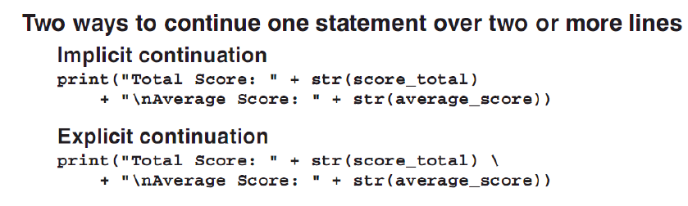

* A shebang statement is included in the source code for Mac OS X and UNIX Python to direct the interpreter of the code. This line is ignored in Windows.
* NOTE: It is recommended to include the shebang so that the Python version can also be declared.

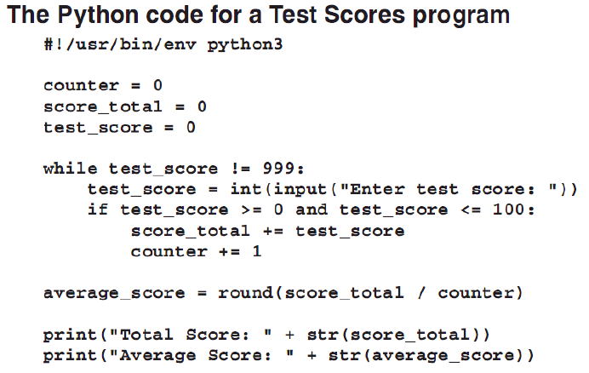

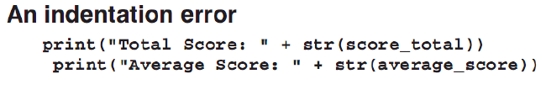

COMMENTS

Comments – used to describe portions of the program.

* Block comment – indicated by a ‘#’ sign in every start of the line of the comment.
* Inline comment – also indicated by ’#’ but put after a statement.

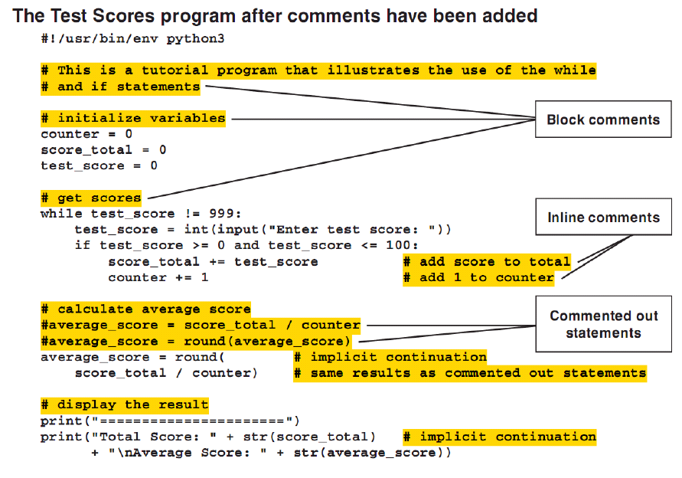

FUNCTIONS

Function – a reusable unit of code and performs a specific task.

* To call a function,

function(argument1, argument 2, …, argumentN).

* The print() displays data followed by a new line.

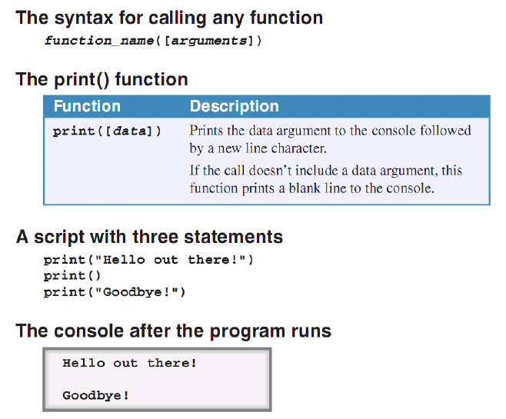

WORKING WITH DATA TYPES

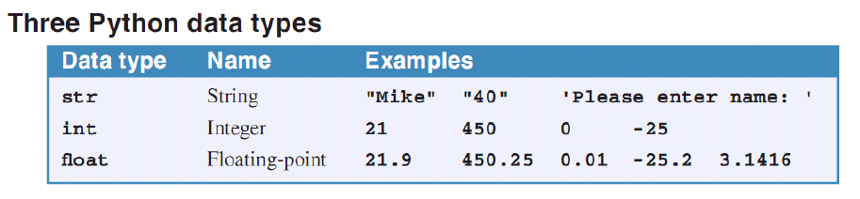

Assignment statements – assigns a value to a variable, variable = value.

* A variable’s value is dynamic and can be changed as the code executes.

Literal values – the values assigned to variables.

* Numeric literals – numbers, 4,3,43.433, etc. They are not wrapped around ‘’.
* String literals – strings enclosed with “” or ‘’, “Johnny”, etc. Use the “”. However, Python style use the ‘’.
* NOTE: Variables are case-sensitive.

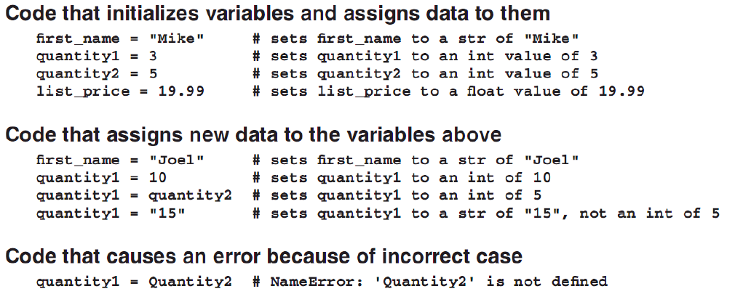

NAMING VARIABLES

* Python programmers use underscore ‘_’ to separate words in variable names. This is called *underscore notation*.
* Variables can also be coded in Pascal case or Camel case.

Rules

* A variable must begin with a letter or underscore.
* A variable can’t contain spaces, punctuation, or special characters other than the underscore.
* A variable can’t begin with a number but it can contain a number.
* A variable name can’t be the same as keyword that’s reserved by Python.

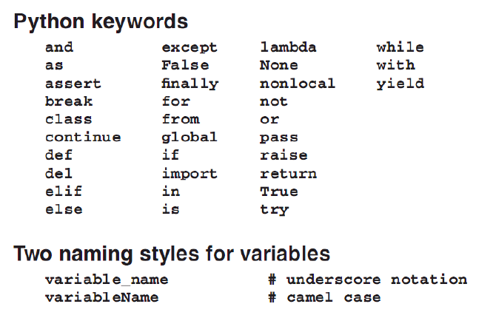

NUMERIC DATA

Numeric expressions – statements that consists of two or more operands that are operated upon by arithmetic operators.

* The operands can be numeric variables or literals.

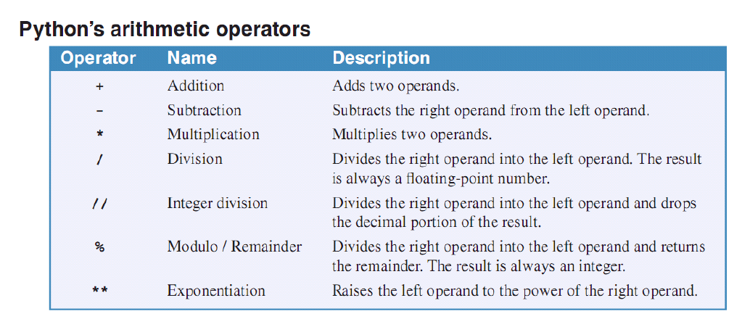

* The // is actually a floor division operator.

Order of Precedence – determines which arithmetic operation is evaluated first.

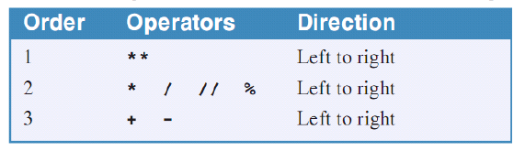

Compound statement – shorthand statements.

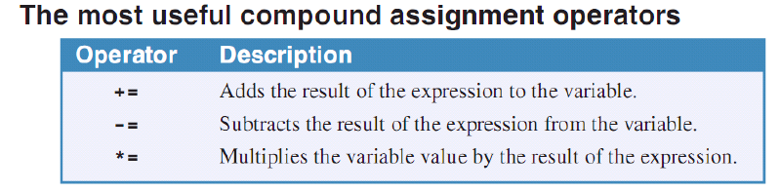

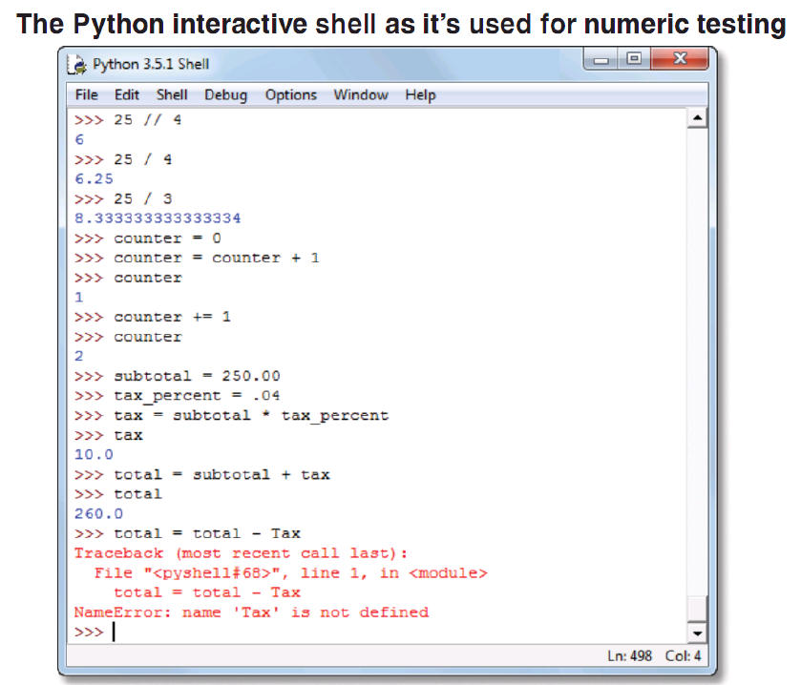

STRING DATA

String – can consist one or more characters.

* An empty string can be created, word = ””.

Joining Strings (Concatenation)

* To concatenate strings, use the ‘+’ operator.

Ex: string1 + “haha” or string2 + string3.

* NOTE: You can’t join a string and a number directly. Use the str() function.
* The str() function converts a number to string that can be operated upon by the concatenation operator.

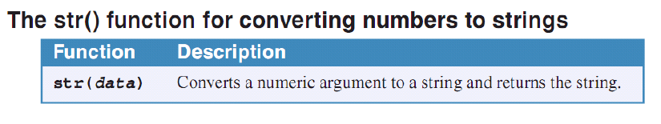

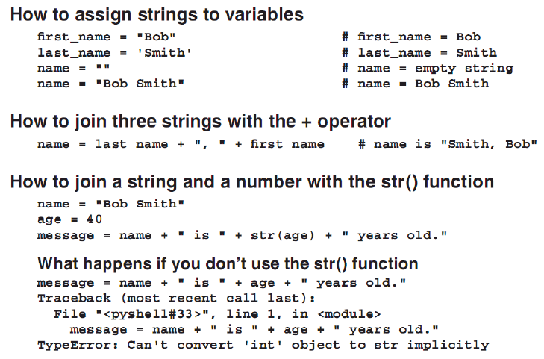

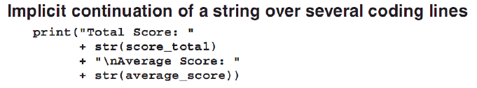

* To include special characters in strings, use escape sequences.

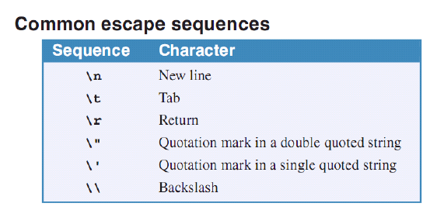

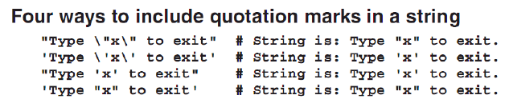

THE PRINT() FUNCTION

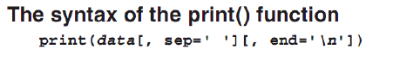

* The sep and end arguments are called *named arguments* since you named them. The sep argument is used to separate the arguments while the end argument is used to end the displayed data.

Ex:

>>> print(1,2,3,4,5,sep='|',end='!!!')

1|2|3|4|5!!!

Named argument – an argument that begins with a name and an equal sign (=).

* You can use the concatenation operator for the arguments of the function since it’s similar to Java and C#. or you can use the comma separator.

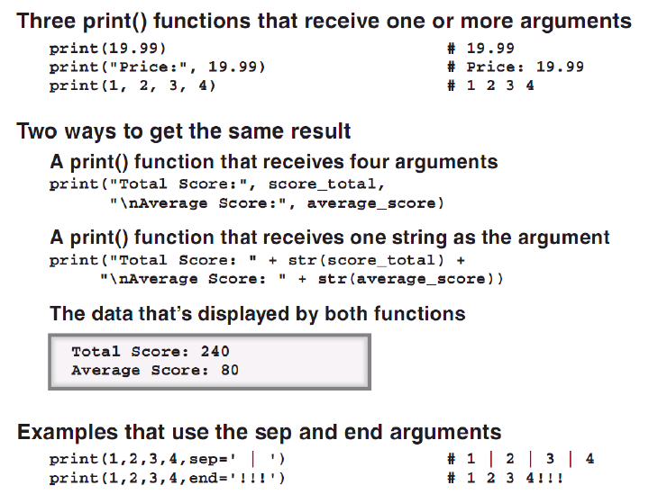

THE INPUT() FUNCTION

* The input() function is used to get data from the user.
* The input() function takes one argument as the prompt for the data request from the user.

Ex:

>>> Name = input("What is your name? ")

What is your name? Ariel.

>>> print("Your name is " + Name)

Your name is Ariel.

* NOTE: All entries to the input() function will be turned to string.

Ex:

>>> Number = input("Give me a number: ")

Give me a number: 5

>>> Number + 4

Traceback (most recent call last):

File "<pyshell#18>", line 1, in <module>

Number + 4

TypeError: must be str, not int

>>> 5 + int(Number)

10

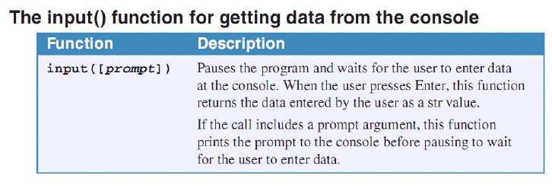

* The input() function can also be used to wait for the user to press enter key.

THE INT(), FLOAT(), AND ROUND() FUNCTIONS

* The int() and float() functions convert data into integer and floating-point, respectively.
* The round() function rounds a numeric value to the specified number of digits.

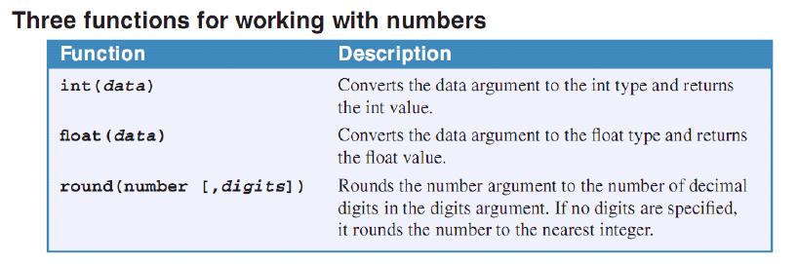

* *Chain Functions* are functions used as arguments of other functions.

Ex:

>>> round(input("GIVE ME A NUMBER: "),5)

GIVE ME A NUMBER: 123.323235465242

Traceback (most recent call last):

File "<pyshell#24>", line 1, in <module>

round(input("GIVE ME A NUMBER: "),5)

TypeError: type str doesn't define __round__ method

>>> round(float(input("GIVE ME A NUMBER: ")),5)

GIVE ME A NUMBER: 123.23434556456345

123.23435

Chapter 3. How to Code Control Statements

Control Statements – lets you control the execution of a program.

Boolean Expressions/Conditional Expressions – expressions that evaluate to True or False based on the results of the comparison of two or more values.

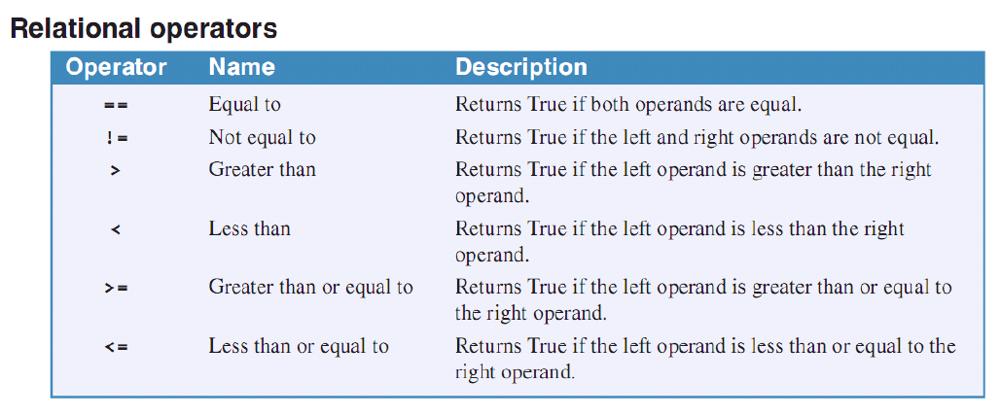

* Floating-point numbers aren’t always exact. Using = or != is not recommended. Use > or < instead.

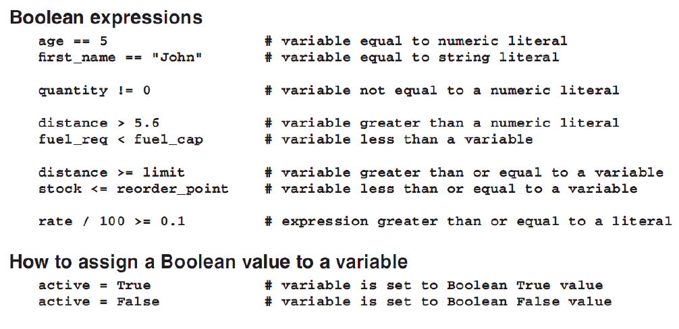

COMPOUND CONDITIONAL EXPRESSIONS

* In coding compound conditional expressions, use the logical operators to combine two or more Boolean expressions.
* Logical operators are typed in lowercase as opposed to other programming languages.
* Short circuit operators – evaluates second operand only based on the evaluation of the first.

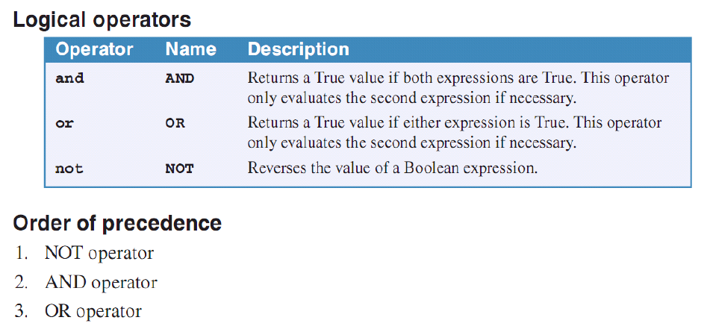

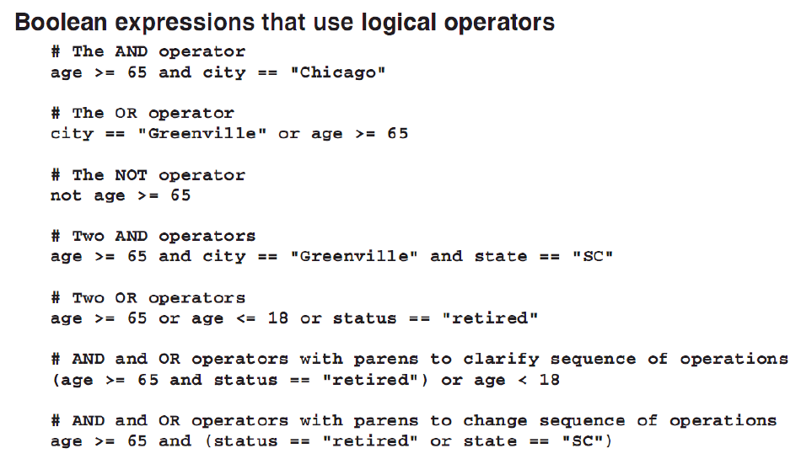

COMPARING STRINGS

* Numbers are compared based on their numeric values. Strings are compared by a character by character basis from left to right.

Sort Sequence – digits are lower than uppercase letters. Uppercase letters are lower than lowercase letters.

* ‘peach’ comes before ‘pear’ but ‘Peach’ comes before ‘apple’.
* NOTE: Sort sequence.
* Use the lower() and upper() method to convert to lowercase and uppercase respectively.
* METHOD vs FUNCTION – method are functions that belong to a class instance, functions are general programming construct.

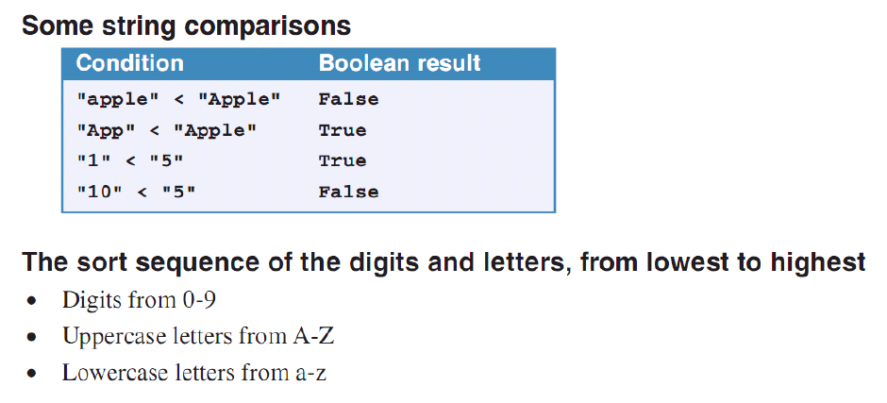

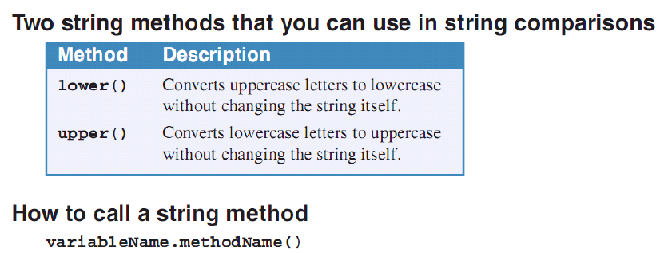

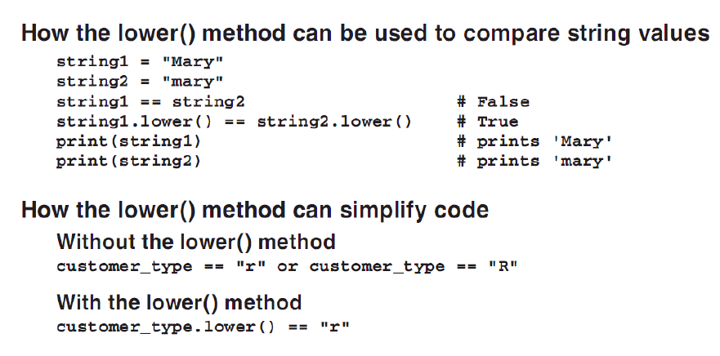

>>> 'This is a string.'.upper()

'THIS IS A STRING.'

>>> 'AAA' < 'aaa'

True

>>> 'AAA' > 'aaa'

False

>>> 'This is another string'.lower()

'this is another string'

* REMEMBER: Convert to lower or uppercase first before comparison!

SELECTION STRUCTURE

IF statement – controls the execution of statements based on the result of a Boolean expression.

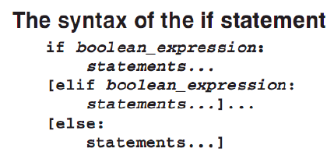

#Demo program for selection structure

#Remember to have same indentation for each substructures!

temperature = int(input('Enter the temperature you want to convert: '))

scale = input('Scale of the temperature [c-Celsius] [f-Fahrenheit]: ')

if scale.lower() == 'c':

fahrenheit = ((9/5)*temperature+32)

if fahrenheit > 50:

print("Wow, that is too hot!")

elif fahrenheit > 25 and fahrenheit <=50:

print("Still too hot.")

else:

print("Nice temperature!")

print("The Fahrenheit equivalence is " + str(fahrenheit))

elif scale.lower() == 'f':

celsius = ((5/9)*(temperature-32))

if celsius > 50:

print("Wow, that is too hot!")

elif celsius > 25 and celsius <=50:

print("Still too hot.")

else:

print("Nice temperature!")

print("The Celsius equivalence is " + str(celsius))

else:

print("That is not a valid choice.")

========================= RESTART: D:/PYTHON/temp.py =========================

Enter the temperature you want to convert: 100

Scale of the temperature [c-Celsius] [f-Fahrenheit]: f

Still too hot.

The Celsius equivalence is 37.77777777777778

>>>

========================= RESTART: D:/PYTHON/temp.py =========================

Enter the temperature you want to convert: 100

Scale of the temperature [c-Celsius] [f-Fahrenheit]: c

Wow, that is too hot!

The Fahrenheit equivalence is 212.0

>>>

========================= RESTART: D:/PYTHON/temp.py =========================

Enter the temperature you want to convert: 300

Scale of the temperature [c-Celsius] [f-Fahrenheit]: d

That is not a valid choice.

>>>

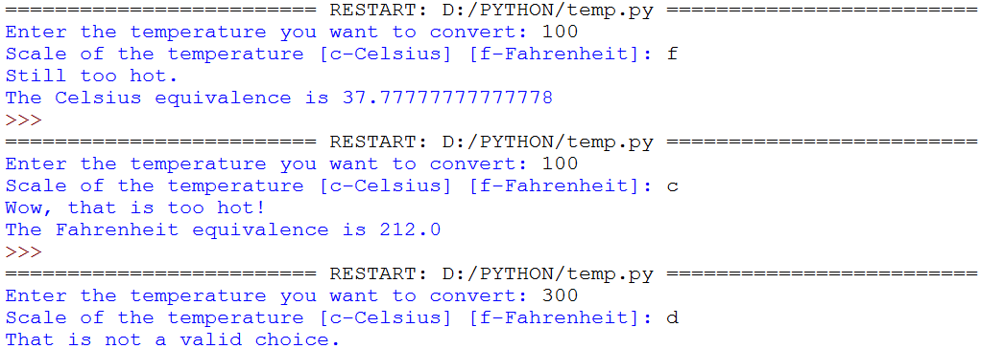

* NOTE: Statements inside the elif statements are only evaluated if the previous if and elifs are evaluated to be False.

DATA VALIDATION

Data Validation – the process of checking if the input of the user is valid or among the possible valid inputs.

* Use the ‘pass’ statement for empty if clauses.

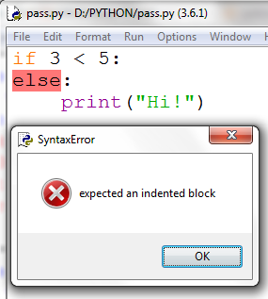

if 3 < 5:

pass

else:

print("Hi!")

OUTPUT:

========================= RESTART: D:/PYTHON/pass.py =========================

>>>

if 3 > 5:

pass

else:

print("Hi!")

OUTPUT:

========================= RESTART: D:/PYTHON/pass.py =========================

Hi!

>>>

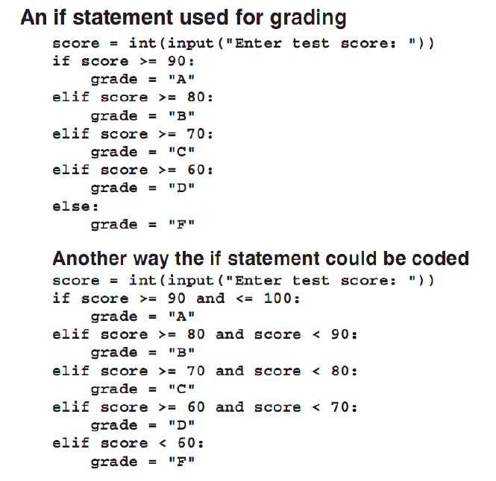

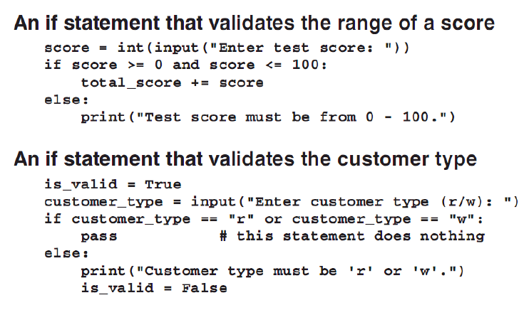

NESTED IF STATEMENTS

* IF statements can be nested. Use the same structure for un-nested IFs.

ITERATION STRUCTURE

Iteration Structures/Repetition Structure – repeatedly execute a block of statements.

* While statements are used to create while loops. They are *condition-controlled loops*.
* *Infinite loop* happens if the while condition doesn’t ever become False.

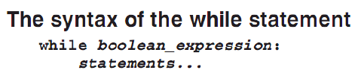

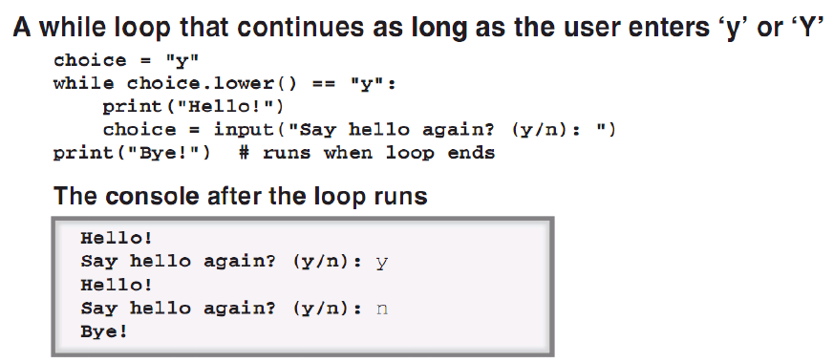

#Fibonacci in a while loop

fibo = 0

prev_el = 1

next_el = 0

while fibo < 1000:

fibo = prev_el + next_el

print(fibo)

prev_el = next_el

next_el = fibo

OUTPUT:

====================== RESTART: D:/PYTHON/fibo_while.py ======================

1

1

2

3

5

8

13

21

34

55

89

144

233

377

610

987

1597

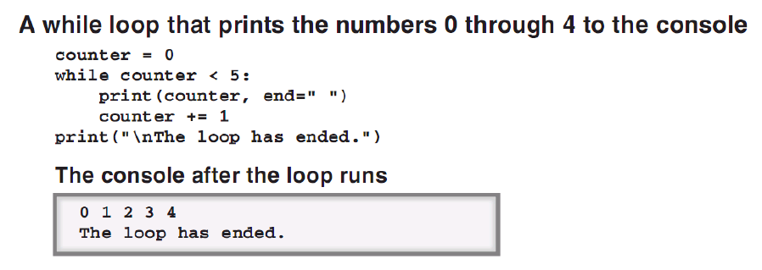

* Use the ‘end’ named argument of print() function to display inline.

#Fibonacci in a while loop

fibo = 0

prev_el = 1

next_el = 0

while fibo < 1000:

fibo = prev_el + next_el

print(fibo, end=" ")

prev_el = next_el

next_el = fibo

OUTPUT:

====================== RESTART: D:/PYTHON/fibo_while.py ======================

1 1 2 3 5 8 13 21 34 55 89 144 233 377 610 987 1597

* Ctrl+C to end infinite loop in Windows.

FOR STATEMENTS

* FOR statements are *collection-controlled loops*.

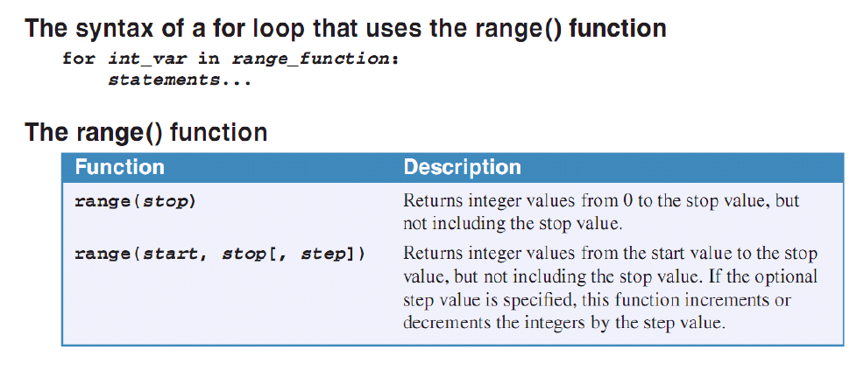

* In Python’s FOR loops, range is used to generate the counter.
* The range() function generates a list of the sequence of numbers specified.

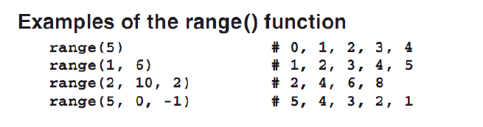

#Demo of FOR loops using Fibonacci

fibo = 0

next_elem = 0

prev_elem = 1

print("Fibonacci sequence with 20 elements:")

#Gives 20 items in the sequence

for x in range(1, 20, 1):

fibo = next_elem + prev_elem

print(fibo, end=" ")

prev_elem = next_elem

next_elem = fibo

OUTPUT:

======================= RESTART: D:/PYTHON/fibo_for.py =======================

Fibonacci sequence with 20 elements:

1 1 2 3 5 8 13 21 34 55 89 144 233 377 610 987 1597 2584 4181

BREAK AND CONTINUE STATEMENTS

Break Statement – breaks out of the loop to jump to the statement that follows the loop. It causes the loop to end.

Continue Statement – continues the loop by causing the execution to jump to the top of the loop. It causes the loop to execute again by reevaluating its condition.

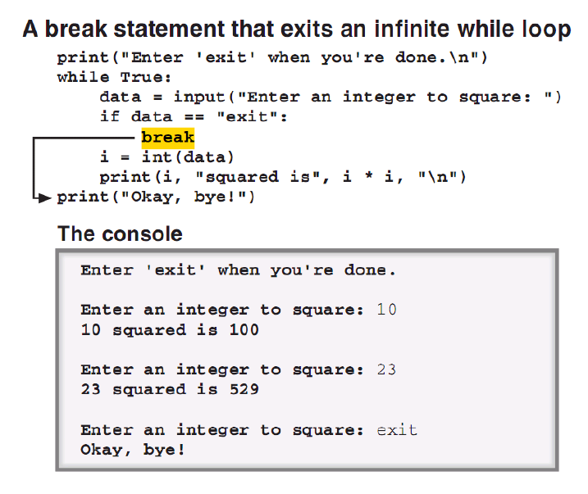

#Bubble sorting demo for the break and continue statements

import random

numbers = [random.randint(1,100) for x in range(1,50)]

print("The numbers unsorted: ", numbers)

holder = 0

iterations = 0

#bubble sorting

sorting_done = False

while not sorting_done:

sorting_done = True

iterations += 1

for x in range(0,len(numbers)-1):

if numbers[x] > numbers[x+1]:

holder = numbers[x]

numbers[x] = numbers[x+1]

numbers[x+1] = holder

sorting_done = False

else:

continue

print("The numbers sorted: ", numbers)

print("Iterations: ", iterations," Elements: ", len(numbers))

OUTPUT:

================ RESTART: D:/PYTHON/bubble_sort_cont_break.py ================

The numbers unsorted: [5, 39, 12, 71, 52, 50, 23, 68, 23, 13, 66, 18, 75, 23, 40, 79, 82, 83, 57, 88, 38, 54, 66, 6, 74, 89, 44, 65, 5, 2, 33, 22, 77, 4, 4, 3, 61, 32, 82, 67, 22, 55, 69, 70, 87, 35, 30, 70, 1]

The numbers sorted: [1, 2, 3, 4, 4, 5, 5, 6, 12, 13, 18, 22, 22, 23, 23, 23, 30, 32, 33, 35, 38, 39, 40, 44, 50, 52, 54, 55, 57, 61, 65, 66, 66, 67, 68, 69, 70, 70, 71, 74, 75, 77, 79, 82, 82, 83, 87, 88, 89]

Iterations: 49 Elements: 49

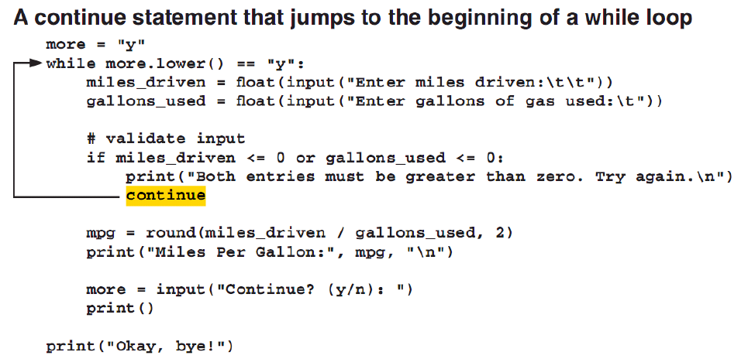

Chapter 4. How to Define and Use Functions and Modules

Function – a unit of code that performs a task. Useful to divide code into manageable chunks. Functions can also be used by more than one program.

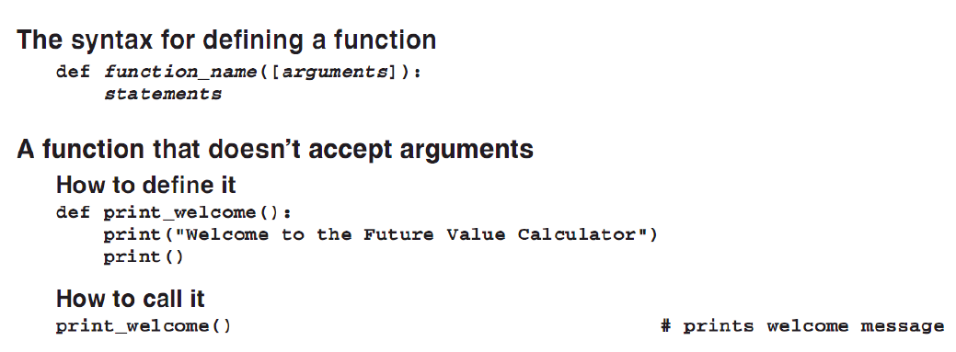

#Demo for a function

#Temperature converter

temp = int(input("Temperature: "))

scale = input("Scale [C][F]: ")

def convert_celsius(temperature):

celsius = (5/9)*(temperature - 32)

return celsius

def convert_fahrenheit(temperature):

fahrenheit = (9/5) * temperature + 32

return fahrenheit

if(scale.lower() == 'f' or scale.lower() == 'c'):

if(scale.lower() == 'c'):

print("CELSIUS: ", temp, " degree Celsius")

print("FAHRENHEIT: ", convert_fahrenheit(temp), " degree Fahrenheit")

else:

print("CELSIUS: ", convert_celsius(temp), " degree Celsius")

print("FAHRENHEIT: ", temp, " degree Fahrenheit")

else:

print("The scale is invalid.")

OUTPUT:

================ RESTART: D:/PYTHON/temp_convert_function.py ================

Temperature: 23

Scale [C][F]: c

CELSIUS: 23 degree Celsius

FAHRENHEIT: 73.4 degree Fahrenheit

>>>

================ RESTART: D:/PYTHON/temp_convert_function.py ================

Temperature: 23

Scale [C][F]: f

CELSIUS: -5.0 degree Celsius

FAHRENHEIT: 23 degree Fahrenheit

* Define functions before using them.
* Use verbs in naming functions.

MAIN FUNCTION

* Always code the non-specific statements to a function inside a main() function.
* NOTE: The main() function must be called to be used after definition.
* Calling the main() function, as it is, is not recommended. What if you imported other modules that have the main() function also? What if other programs import your module and it contains the main() function?

Module – a file that contains reusable code like a function. It’s like *packages* for other programming languages.

* Check if the __name__ is equal to __main__ first.

#This is the first module. It will be imported by

#a second module.

#Notice that the bare ‘main()’ statement is used.

#Demo for a function

#Temperature converter

def main():

temp = int(input("Temperature: "))

scale = input("Scale [C][F]: ")

if(scale.lower() == 'f' or scale.lower() == 'c'):

if(scale.lower() == 'c'):

print("CELSIUS: ", temp, " degree Celsius")

print("FAHRENHEIT: ", convert_fahrenheit(temp), " degree Fahrenheit")

else:

print("CELSIUS: ", convert_celsius(temp), " degree Celsius")

print("FAHRENHEIT: ", temp, " degree Fahrenheit")

else:

print("The scale is invalid.")

def convert_celsius(temperature):

celsius = (5/9)*(temperature - 32)

return celsius

def convert_fahrenheit(temperature):

fahrenheit = (9/5) * temperature + 32

return fahrenheit

#Not recommended

main()

#Second module. This imports the first module.

#Notice the display depending on how the

#main() call was used in first module.

import temp_convert_function

def main():

print("Hello.")

main()

OUTPUT:

========================== RESTART: D:/PYTHON/d.py ==========================

Temperature: 23

Scale [C][F]: f

Hello.

#MODIFIED FIRST MODULE

#Demo for a function

#Temperature converter

def main():

temp = int(input("Temperature: "))

scale = input("Scale [C][F]: ")

if(scale.lower() == 'f' or scale.lower() == 'c'):

if(scale.lower() == 'c'):

print("CELSIUS: ", temp, " degree Celsius")

print("FAHRENHEIT: ", convert_fahrenheit(temp), " degree Fahrenheit")

else:

print("CELSIUS: ", convert_celsius(temp), " degree Celsius")

print("FAHRENHEIT: ", temp, " degree Fahrenheit")

else:

print("The scale is invalid.")

def convert_celsius(temperature):

celsius = (5/9)*(temperature - 32)

return celsius

def convert_fahrenheit(temperature):

fahrenheit = (9/5) * temperature + 32

return fahrenheit

#Not recommended

#main()

#Recommended

if __name__ == "__main__":

main()

#Second module. This imports the first module.

#Notice the display depending on how the

#main() call was used in first module.

import temp_convert_function

def main():

print("Hello.")

if __name__ == "__main__":

main()

========================== RESTART: D:/PYTHON/d.py ==========================

Hello.

* NOTE: Put all other statements not included in a function inside the main() function. When the module is imported, any statements outside the main() function will be executed.

DEFAULT VALUES FOR ARGUMENTS

* When defining functions, a default value can be assigned to one or more parameters. Use the assignment operator ‘=’.
* The parameters with the default values must be put on the end of the parameter list.
* Default values can be overridden.
* Named arguments/parameters are used so that the sequence of the arguments in the function call is disregarded. Use the assignment operator in the function call ‘=’. FORMAT: name=argument.

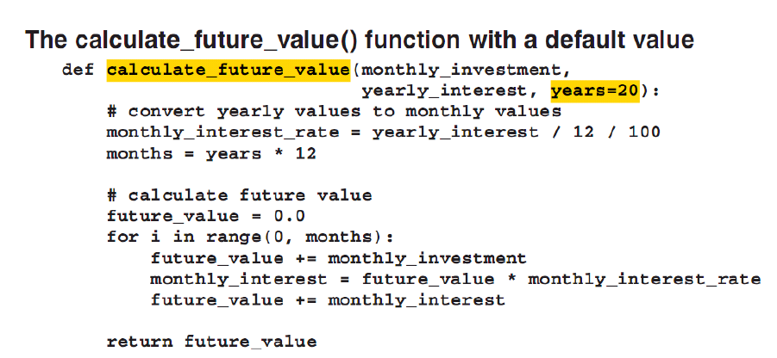

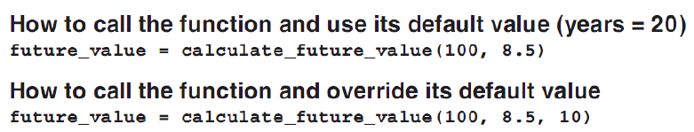

LOCAL AND GLOBAL VARIABLES

Scope – visibility of the variables.

Global variables – variables that are defined outside all functions. These variables have global scope so they can be accessed anywhere in the program.

Local variables – variables that are defined within functions. These variables have local scope which means they can only be used within their functions or blocks.

* RECOMMENDED: Avoid global variables.
* Accessing global variables is different in Python. It must be explicit (as pointed in the design philosophy). Use the *global* keyword to access global variables. FORMAT: global global_variable.
* If the function has a variable with the same name as the global variable and the global keyword was not used, then the local variable’s value will be considered.

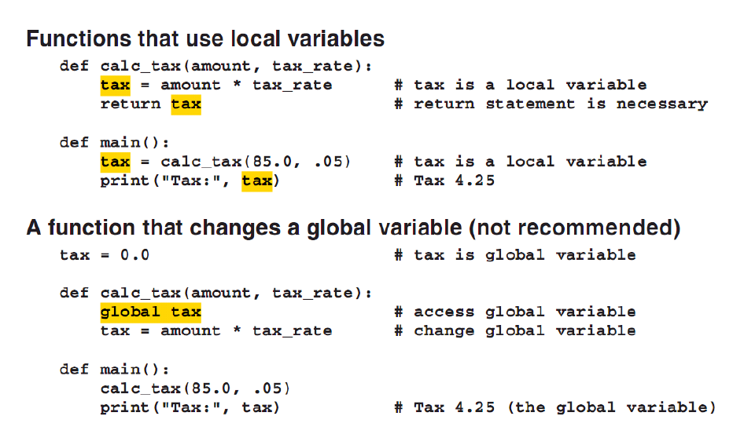

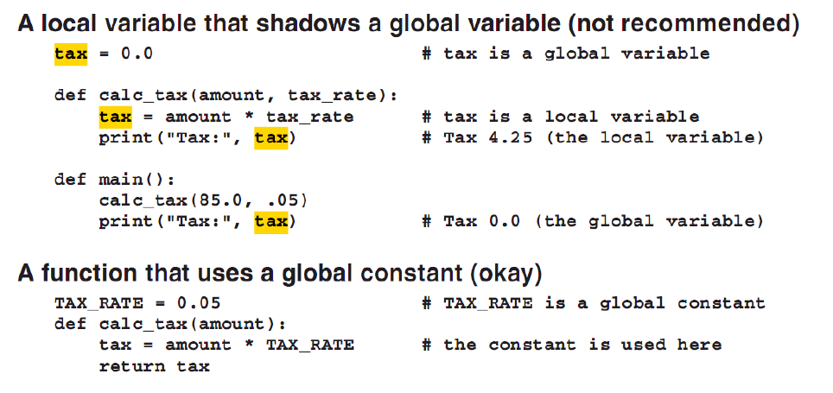

* For constants, add *global constants*. The convention is the same as other programming languages. Name the constant with uppercase letters only and with words delimited by underscore.
* Global constants’ values can technically be changed. However, they are still global variables inside functions. Without the *global* keyword, the values cannot be changed. Brilliant.
* RECOMMENDED: Use global constants instead.

#Demo global variables

global_variable = 3.14

def number():

global_variable = 2 #shadows global variable

print(global_variable)

number()

print(global_variable)

OUTPUT:

====================== RESTART: D:/PYTHON/global_var.py ======================

2

3.14

#Demo global variables

global_variable = 3.14

def number():

global global_variable #use the global variable instead

global_variable = 2 #shadows global variable

print(global_variable)

number()

print(global_variable)

OUTPUT:

====================== RESTART: D:/PYTHON/global_var.py ======================

2

2

* Technically, the *global* keyword declares the global variable as local variable inside the function.
* NOT REALLY RECOMMENDED. Use global constants instead.

#Demo global variables

global_variable = 3.14

GLOBAL_CONSTANT = 9

def number():

global global_variable #use the global variable instead

global_variable = 2 #shadows global variable

print(global_variable)

print(GLOBAL_CONSTANT)

number()

print(global_variable)

====================== RESTART: D:/PYTHON/global_var.py ======================

2

9

2

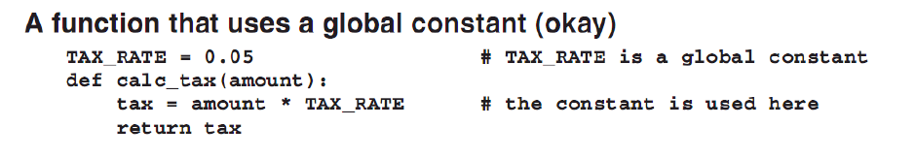

USING AND CREATING MODULES

Module – a file that contains reusable code.

Parts of a Module:

1. Functions. Reusable code.
2. Global constants
3. Main function. Primarily used to test the module.
4. Check code if the module is the main module.

* To create a module, design the program for reusability. The functions must be coherent. It must have the main() function to check the functions and the checking code to check if the module is the main module.

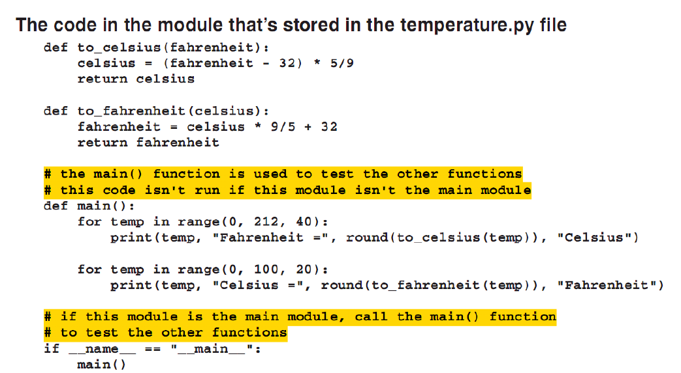

* The name of the module is the name of the file. Save wisely.
* It is recommended to store the module within the same directory of the other modules that will import it.
* Put the module in the search path so other programs in different directories can use it.

DOCUMENTING A MODULE

* If the module will be used by other programmers, it is better to document the functions.
* *Docstrings* are used to document functions. These are declared by “””documentation”””.

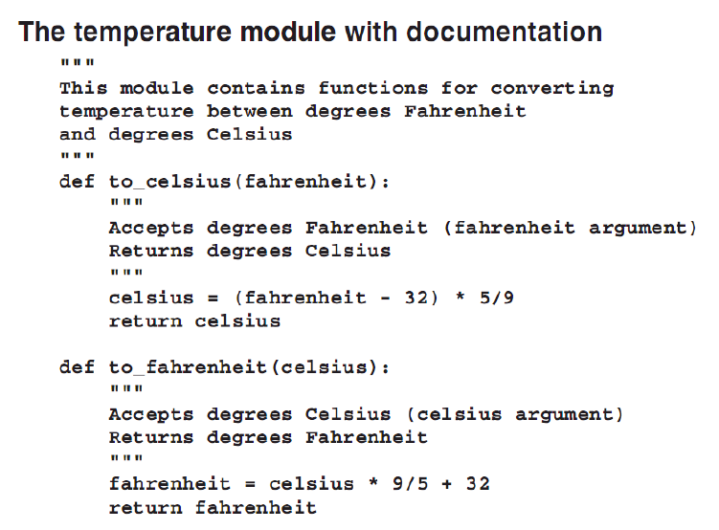

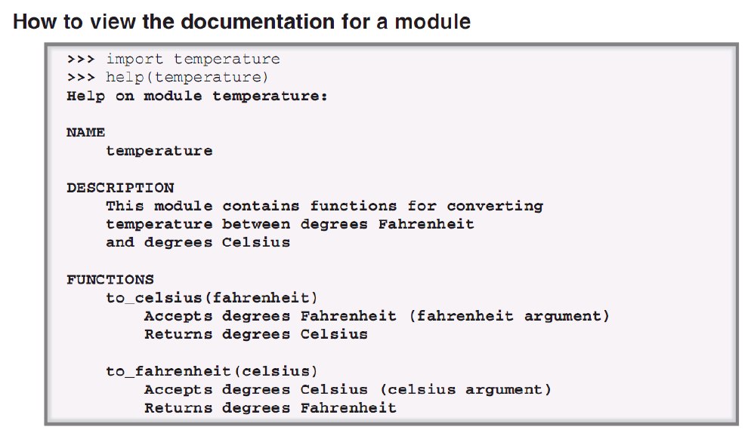

#Demo for a function

#Temperature converter

"""A module for converting temperature from Celsius to Fahrenheit and vice versa."""

def main():

temp = int(input("Temperature: "))

scale = input("Scale [C][F]: ")

if(scale.lower() == 'f' or scale.lower() == 'c'):

if(scale.lower() == 'c'):

print("CELSIUS: ", temp, " degree Celsius")

print("FAHRENHEIT: ", convert_fahrenheit(temp), " degree Fahrenheit")

else:

print("CELSIUS: ", convert_celsius(temp), " degree Celsius")

print("FAHRENHEIT: ", temp, " degree Fahrenheit")

else:

print("The scale is invalid.")

#DOCSTRING

def convert_celsius(temperature):

"""Converts the value of the 'temperature'

variable into Celsius. It returns the Celsius value."""

celsius = (5/9)*(temperature - 32)

return celsius

def convert_fahrenheit(temperature):

"""Converts the value of the 'temperature'

variable into Fahrenheit. It returns the Fahrenheit value."""

fahrenheit = (9/5) * temperature + 32

return fahrenheit

#Not recommended

#main()

#Recommended

if __name__ == "__main__":

main()

INTERACTIVE PROMPT:

>>> import temperature

>>> help(temperature)

Help on module temperature:

NAME

temperature - A module for converting temperature from Celsius to Fahrenheit and vice versa.

FUNCTIONS

convert_celsius(temperature)

Converts the value of the 'temperature'

variable into Celsius. It returns the Celsius value.

convert_fahrenheit(temperature)

Converts the value of the 'temperature'

variable into Fahrenheit. It returns the Fahrenheit value.

main()

FILE

d:\python\temperature.py

* REMEMBER: Make a docstring for the module and each of the functions.
* Use the help(module_name) function to display the docstrings for the module.
* Import the module first before using help.

IMPORTING A MODULE

* If the program needs other functions found in other modules, the modules must be imported.

Importing a module:

1. Using the *import* keyword

Namespace – area in the memory that holds a module (may be different from the other definition of namespaces in other programming languages).

* When using *import*, the imported module can be placed to a specified namespace.
* By default, the import statement imports a module into a namespace that has the same name as the module.

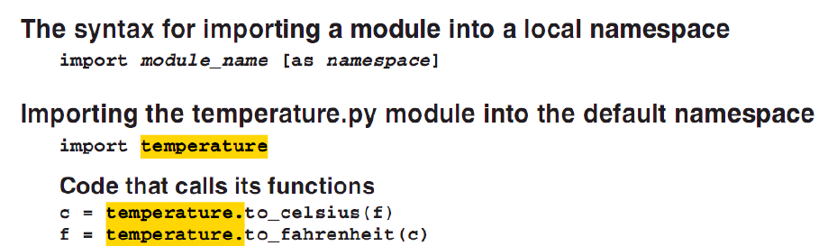

* When the *as* clause is used, the module is imported into the namespace specified.

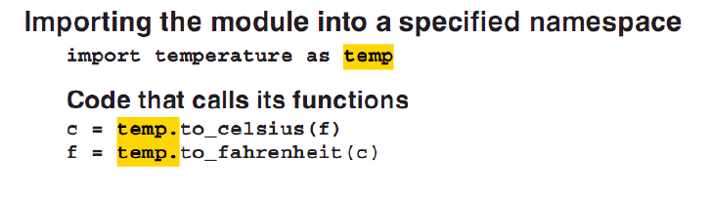

* If the *as* clause is used, use the new namespace when accessing the functions.
* Use dot operator when accessing members of a module.

1. Using the *from* variation of the *import* keyword

* Using this, the module is imported to the global namespace.
* RECOMMENDED: Avoid global namespace. Name collision may occur if multiple modules are imported to global namespaces.

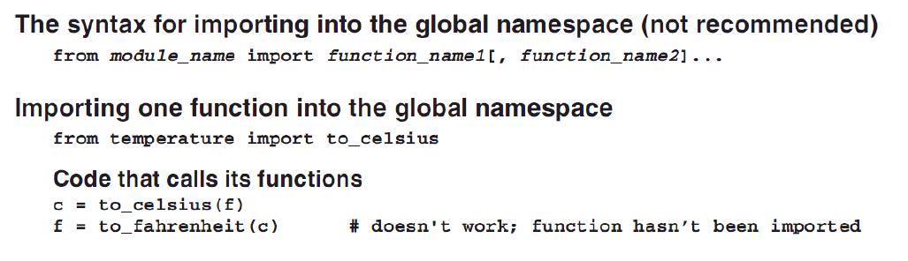

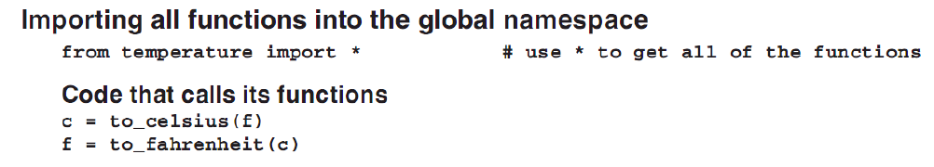

* If imported to the global namespace, the functions are not required to be fully qualified when being called. *They are in the global namespace.*
* Use the * operator to import all members of the module using the *from* variation.

STANDARD MODULES

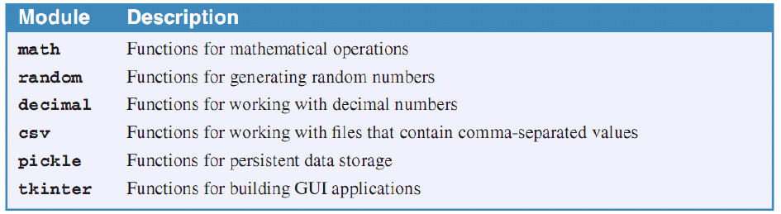

* These are some of the standard modules included in the book.

A. RANDOM MODULE

* Import the random module by: *import random*.
* It has three commonly used functions:
  + random() – returns a float number ranging from 0.0 to 1.0. TIP: multiply the random() return by any number *n* to have a possible value between 0.0 to *n*. Ex: random()*100 = 0.0 to 100.0 or random()*50 = 0.0 to 50.0. This is just like percentage.
  + randint(min, max) returns an integer from *min* to *max*.
  + randrange([start,] stop [,step]) – returns a number between start and stop. One difference is it can filter numbers because of the *step* argument. The step removes numbers in between.

PLANNING A PROGRAM

* To plan the functions of a program, a hierarchy chart can be used.
* Begin with *main* function as the top of the hierarchy. Put the directly called functions under main. Consider the levels. If a function is called in another function, then it is below the calling function.
* QUESTION: What if *main* called a function that is also called by another?
* This hierarchy chart is suited for small programs.
* Use multiple assignments

x, y, z = 1, 2, 3

print (x,y,z, sep=” “)

1 2 3

* NOTE: A *return* statement can return multiple values.

Chapter 5. How to Test and Debug a Program

* In testing a program, you make sure that all possible combination of input data and user actions are tried to be certain that the program works in every case.
* The goal of testing is to make the program fail.
* Debugging – fixing errors (bugs) that are discovered during the testing.
* Each time a bug is fixed, test again to make sure that the change incurred did not affect other aspects of the program.

TYPES OF ERROR

1. Syntax error – prevents the program from compiling and running. It happens when Python attempts to compile a program that’s why it is also known as *compile-time errors*.
2. Runtime error – an error that can’t be detected until the program is run. It throws *exceptions* to stop the execution of the program.
3. Logic error – an error that doesn’t stop the program from compiling and doesn’t throw any exceptions. This is an error with the *logic* or *design* of the program.

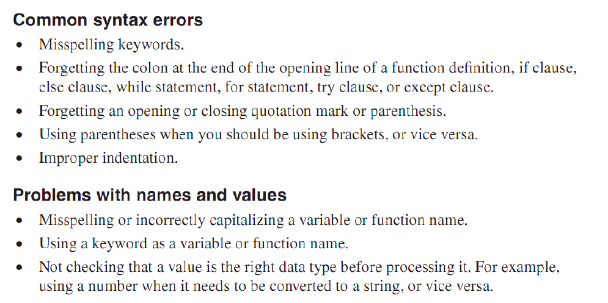

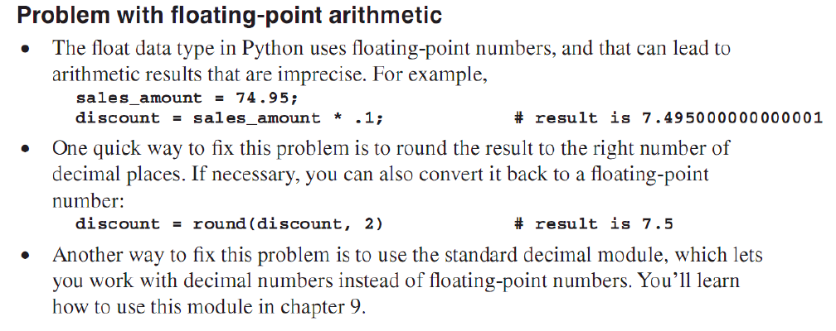

PLANNING TEST RUNS

1. Test the program with valid data (preferably, a range).
2. Test the program with invalid data.

* Test plan – a table or spreadsheet that shows what test data is going to be entered and what the results should be.
* Tracing the program means adding print() functions to some critical parts of the program to track the changes in data.

TOP DOWN CODING AND TESTING

* Top down coding or top down testing means testing just a small portion of a program at a time.
* Divide the program into functions.

METHODOLOGY

1. Code one or two functions inside the main() function.
2. Code the added functions and adjust the main() function.
3. Code and test the functions including the main() function.

* Test the functions one at a time before proceeding to same-level functions.

TESTING WITH THE IDLE

* Import the Python script first.
* Run the individual functions and their needed arguments (put test data on the argument list).
* If a program is being tested, run it. If it is a module, import it.

IDLE DEBUGGER

* Set breakpoints.
* To set a breakpoint, right-click on a statement in the IDLE editor and select *Set Breakpoint*.

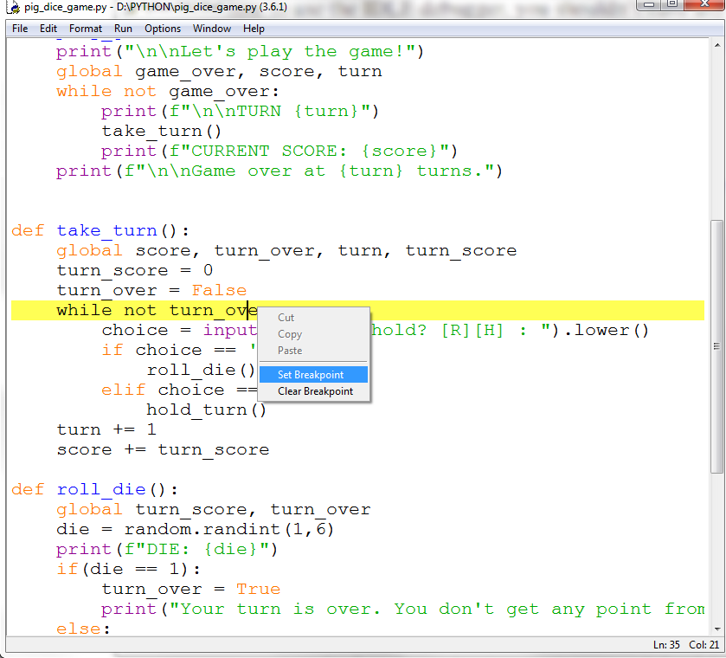

* Open the IDLE Debugger on the Python Shell. *Debug -> Debugger*.

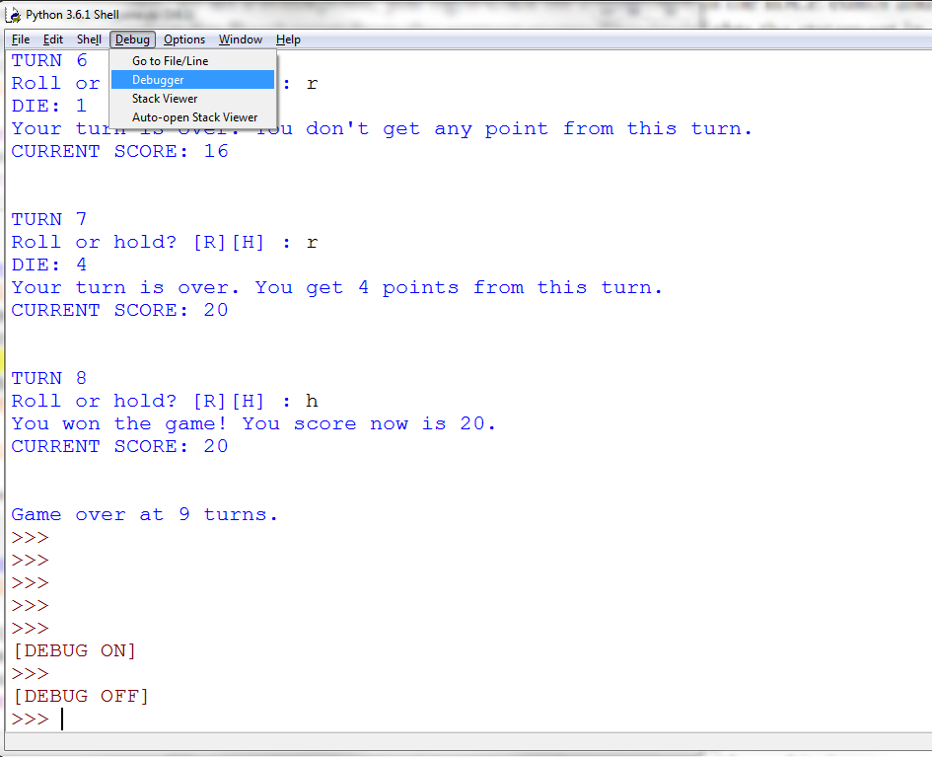

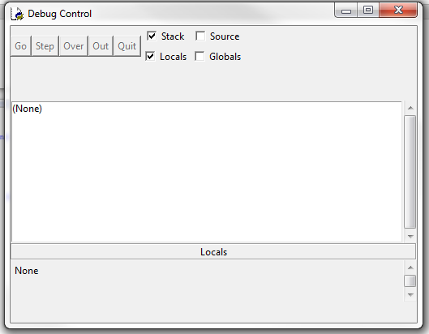

* Make sure that *Source* is checked on the Debug Control window. This makes sure that the text editor highlights the statement that’s going to be executed next, and the debugger will automatically open any modules that are used by the program when needed.

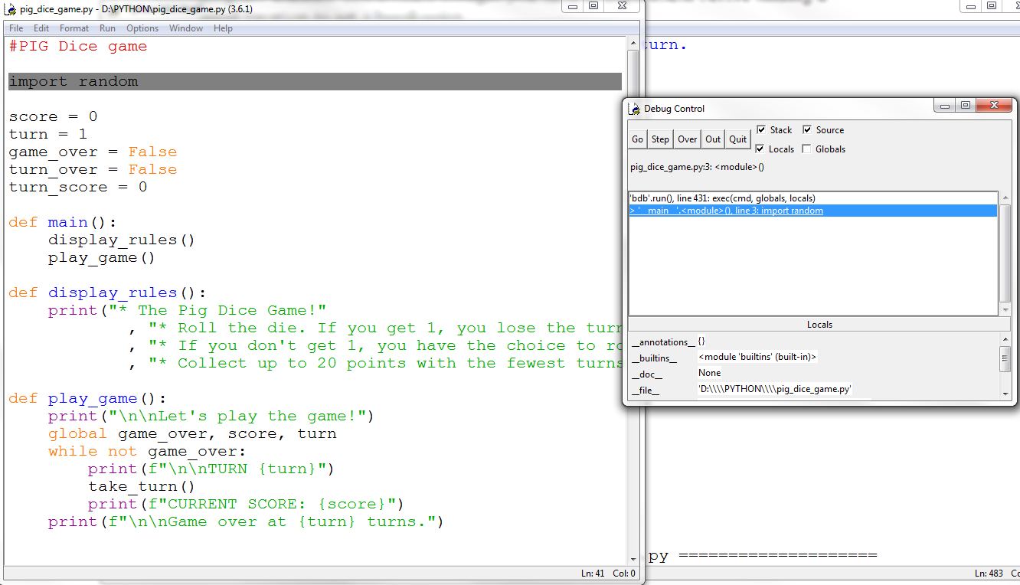

* Run the program from the IDLE editor. The debugging will proceed after the *Go* button is pressed. The program will run until the first breakpoint is reached.

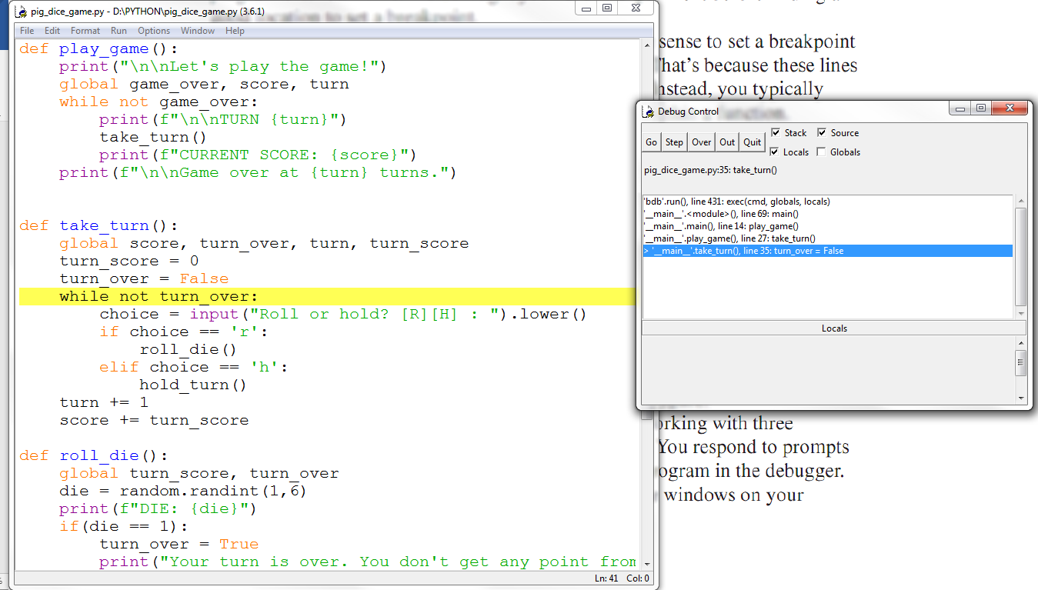

DEBUG CONTROLS

1. Step through – step into the function and statements one at a time. Use the *Step* button.
2. Step over – execute a function without stepping into it and automatically perform the function without having to step through every statement inside. Use the *Over* button.
3. Go – proceed with the normal execution of the program until the next breakpoint is reached. Use the *Go* button.
4. Quit – terminates the execution of the program. Use the *Quit* button.

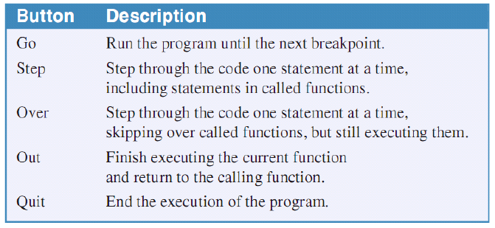

* The global and local variables and their values can be seen in their respective boxes. Mark the proper boxes to view them.

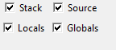

VIEWING THE STACK

* The stack is a list of the functions that have just been executed in reverse sequence in which they were called.

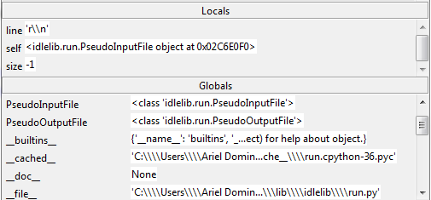

* To open the stack viewer on the Python Shell, *Debug* -> *Stack Viewer.*

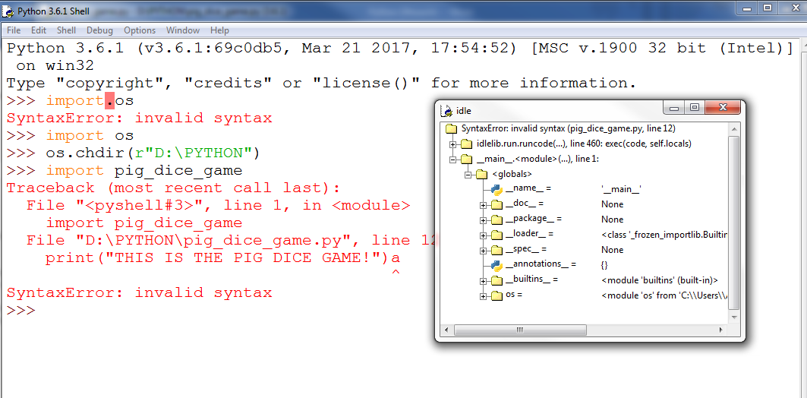

* Use the Stack Viewer when an exception is thrown.
* To automatically open the Stack Viewer whenever an exception occurs, select *Debug* -> *Auto-open Stack Viewer*.

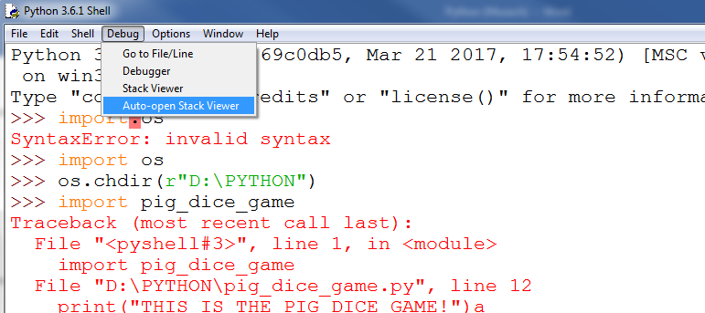

Chapter 6. How to Work with Lists and Tuples

* List – a collection of items. It is also called as a *sequence* since it stores the items in the order they were placed inside it. It has the analogy of an array and elements of the other languages.
* To create a list, enclose the items with [] and separated with commas.
* A list can contain elements with different data types like strings and integers.

list1 = [0,"Hello", "World", 34.233]

print(list1)



* A list with no element can also be created.

list1 = []

print(len(list1))



* To create a list with repeated elements, use the * operator.

list1 = [0] * 4

print(list1)



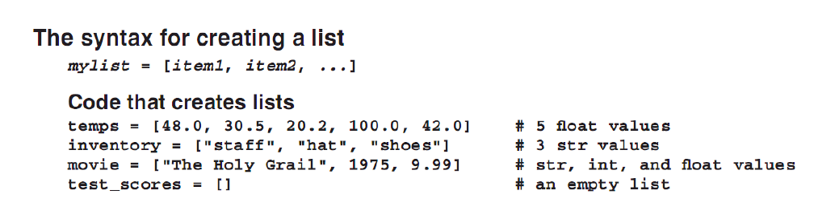



* To reference an item in the list, use an *index* just like in other programming languages. It also starts with 0, from left to right.
* Use negative index to reference the items from right to left beginning with -1.

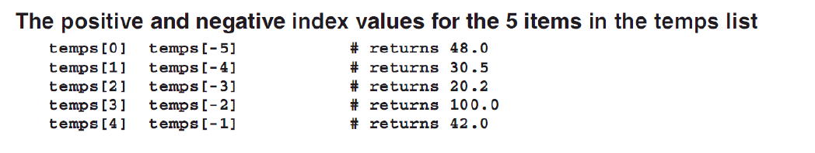

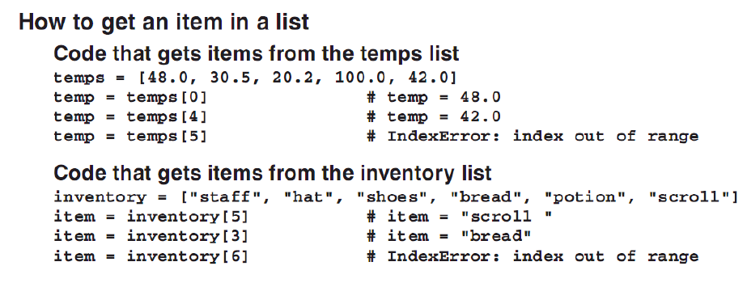

* The items in the list can be obtained and set. To set the specific item position, reference the position first and then use the assignment operator.

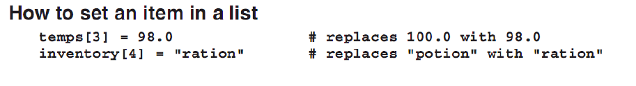

* Set the item position just like setting in other programming languages.

LIST METHODS FOR MODIFYING A LIST

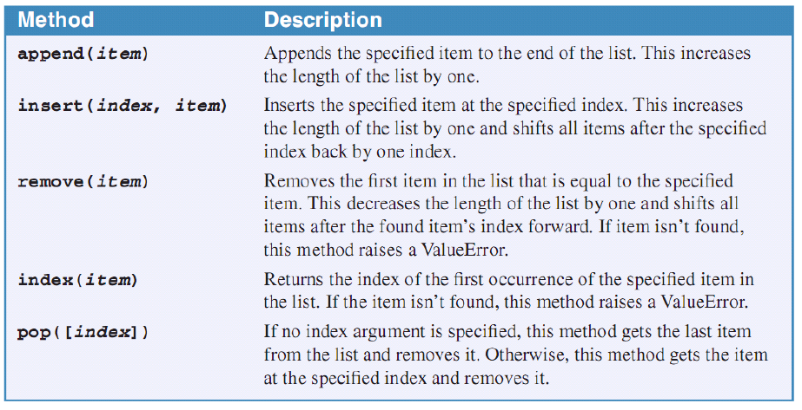

* list.append(item) – puts the item at the end of the list and increase the length of the list.
* insert(index, item) – insert the item at the the position set by index. Remember that a list starts with 0.
* remove(item) – removes the first item in the list that matches the item argument. Else, it raises a ValueError. It decreases the size of the list by one and shift all items to the left (0-len(list)).
* Index(item) – returns the index of an item that is the same with the item argument. It raises a ValueError if no item is found.
* pop([index]) – just like remove(item) but using index instead. If used without argument, the last item will be removed.

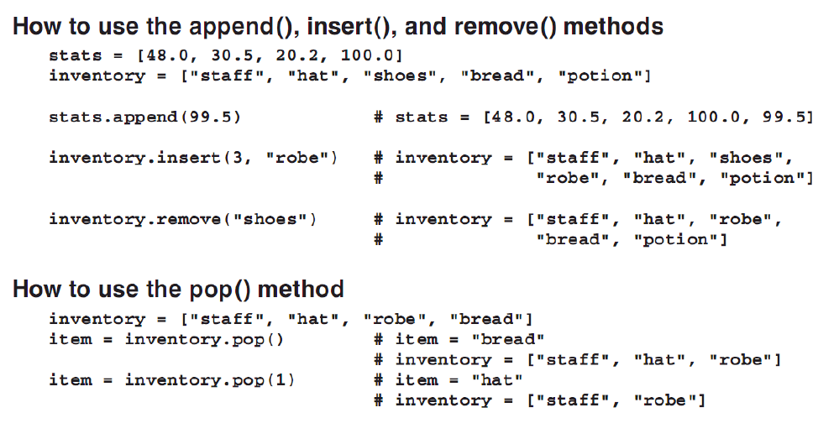

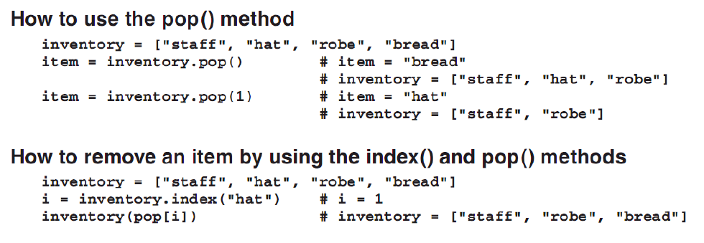

PROCESSING ITEMS IN THE LIST

* To check for the number of items in a list, use the len() function.

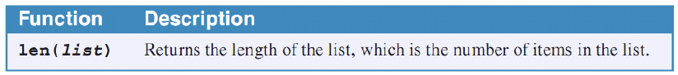

* To check if an item is in the list, use the *in* keyword.

#Checking if an item exists in a list1

fruits = ["apple", "orange", "mango"]

fruit = "apple"

if fruit in fruits:

print(f"The {fruit} is in the fruit list!")

else:

print(f"The {fruit} is not in the fruit list.")



* The *in* keyword is used to traverse the items of a list. In the *for* loop, all items in a list are being processed with the number of iteration the same as the length of the list.
* The *in* keyword used in an *if* statement looks for the item in the list. If the item exists, then the *if* statement’s body is executed.
* To print the list, use the print(list) function.

#Checking if an item exists in a list1

fruits = ["apple", "orange", "mango"]

fruit = "apple"

if fruit in fruits:

print(f"The {fruit} is in the fruit list!")

else:

print(f"The {fruit} is not in the fruit list.")

print(fruits)

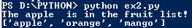

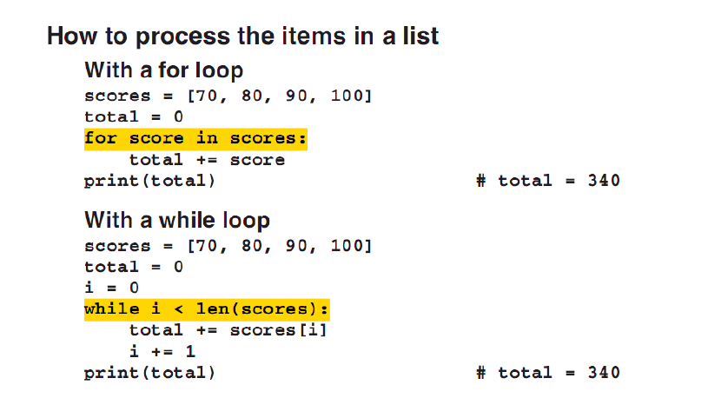

#Processing items in a list

import random

numbers = []

#Generate random numbers

for x in range(0,100):

numbers.append(random.randint(1,100))

#Processing the list, separating the odd and the even numbers.

#Odd number separation

odd_numbers = []

even_numbers = []

for number in numbers:

if number % 2 != 0:

odd_numbers.append(number)

numbers.remove(number)

else:

even_numbers.append(number)

print(len(numbers))

print(len(even_numbers))

print(len(odd_numbers))

print("The odd numbers are: ", odd_numbers)

print("The even numbers are: ", even_numbers)

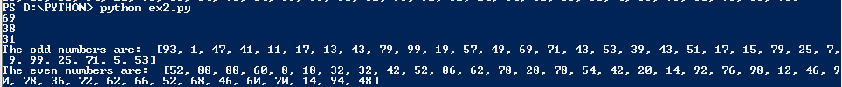

HOW LISTS ARE PASSED TO FUNCTIONS

* Python uses *objects* to store data of all data types.
* The “string” is a *string* object. This is the *str* type.
* 1 is an *int* object.
* Most of the time, an object is assigned to a variable.

MUTABLE AND IMMUTABLE OBJECTS

* The str, int, float, and bool data type objects are immutable. The data that is stored in their created objects cannot be changed.
* The data can be changed if the object is mutable.
* A list object is mutable. When an item is appended to the list using the append() function, then the data is mutating, thus a list is a mutable type.
* Mutable objects are passed by reference to functions while immutable objects are passed by value.

LIST OF LISTS

* A list of lists can be created by inserting a list as an item to a list.
* A list of lists is a two-dimensional list.

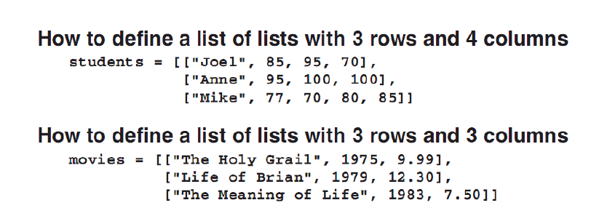

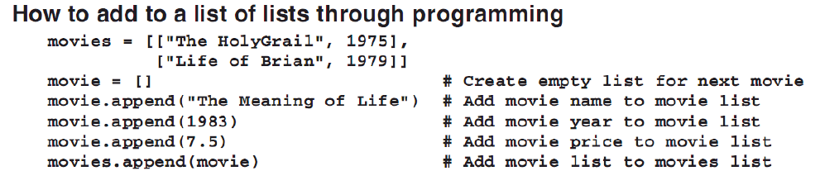

PROCESSING ITEMS IN A LIST OF LISTS

* If *n-dimensional* list, use a *n* indexed list.

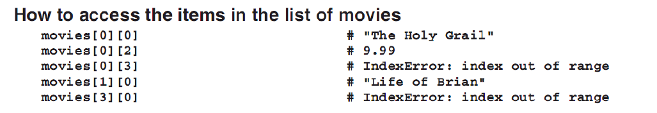

* A *n-dimensional list* can be printed using the print() function.
* A for loop can also be used to process lists inside a list.

#Processing list of lists

people = [["Ariel Catli", 22, "774 Real St., Intramuros, Manila"], \

["Joshua Viterbo", 23, "774 Real St., Intramuros, Manila"]]

print(people)

for person in people:

for information in person:

print(information)

print("\n")

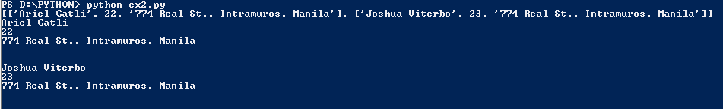

OTHER LIST FUNCTIONS

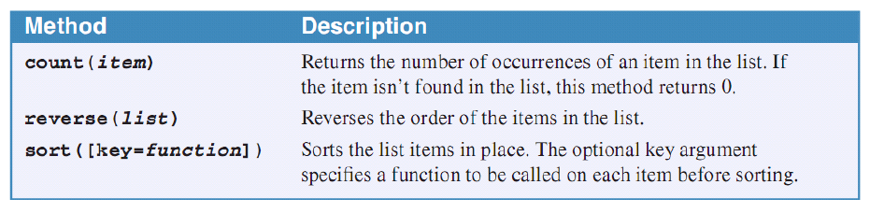

* The list.count(item) function returns the number of the occurrence of an item in the list. It is case-sensitive.

#Skills in processing a list

people = ["Ariel", "Joshua", "Marvin", "Paul", "Rafael", "Ariel"]

print(people.count("Pauline"))

print(people.count("Joshua"))

print(people.count("Ariel"))

print(people.count("ariel"))

#The list.count() function is case-sensitive

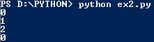

* The list.reverse() function is used to reverse the order of items in the list. However, this function cannot be used with the print() function directly. There is a return to this function that’s why before displaying the reverse of the list, use the list.reverse() function first then use the print(list).

#Skills in processing a list

import random

people = ["Ariel", "Joshua", "Marvin", "Paul", "Rafael", "Ariel"]

numbers = []

#Generate a list of numbers

for x in range(0,10):

numbers.append(random.randint(1,100))

print(people)

people.reverse()

print(people.reverse())

print(people)

print(numbers)

numbers.reverse()

print(numbers)

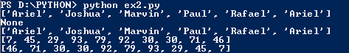

* The list.sort([key=function]) sorts the items in the list. The key parameter means the function (which is the argument) will be called first for the items of the list before sorting. Best example is the str.lower function. This is because of the sort sequence rule in Python. ‘Pearl’ comes before ‘apple’. Number -> Capital letter -> small letters. The key argument does not really change the items.
* Just like the previous functions, you cannot print the results directly using the print() function.

#Skills in processing a list

import random

people = ["Ariel", "Joshua", "Marvin", "Paul", "Rafael", "Ariel", "maria"]

numbers = []

#Generate a list of numbers

for x in range(0,10):

numbers.append(random.randint(1,100))

print("The unsorted names: ", people)

#No key argument

people.sort()

print("The sorted names without the key argument: ", people)

#With key argument

people.sort(key=str.lower)

print("The sorted names with the key argument, str.lower: ", people)

print("The unsorted numbers: ", numbers)

numbers.sort()

print("The sorted numbers: ", numbers)



BUILT-IN FUNCTIONS FOR PROCESSING LISTS

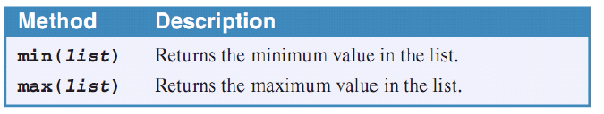

* The min() and max() functions return the smallest and the largest item in the list.
* Remember that these are built-in functions and not methods of a list.

#Skills in processing a list

import random

people = ["Ariel", "Joshua", "Marvin", "Paul", "Rafael", "Ariel", "maria"]

numbers = []

#Generate a list of numbers

for x in range(0,10):

numbers.append(random.randint(1,100))

print("The numbers: ", numbers)

print(f"The smallest number is {min(numbers)} and the largest number is {max(numbers)}.")



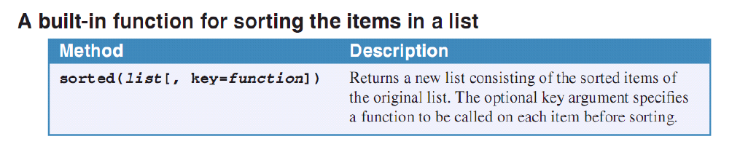

* The sorted() function is a built-in function. It is not a function of a list.
* This has the same function as the list.sort(). However, when the function is used, a new list is created.
* The key argument can also be used in the sorted() function.
* NOTE: sorted() is a built-in function and not a function of a list. It creates a new list while list.sort() changes the list.

#Skills in processing a list

import random

people = ["Ariel", "Joshua", "Marvin", "Paul", "Rafael", "Ariel", "maria"]

numbers = []

#Generate a list of numbers

for x in range(0,10):

numbers.append(random.randint(1,100))

print("The unsorted names: ", people)

#No key argument

sorted_people = sorted(people)

print("The sorted names without the key argument: ", sorted_people)

print("The old list: ", people)

#With key argument

sorted_people = sorted(people, key=str.lower)

print("The sorted names with the key argument, str.lower: ", sorted_people)

print("The old list: ", people)

print("The unsorted numbers: ", numbers)

sorted_numbers = sorted(numbers)

print("The sorted numbers: ", sorted_numbers)

print("The old list of numbers: ", numbers)

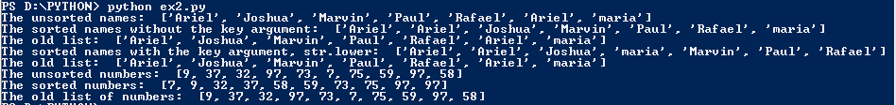

RANDOM MODULE FUNCTIONS FOR LISTS

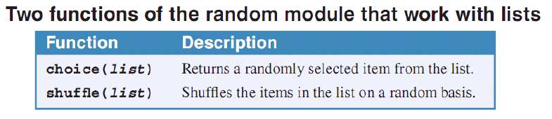

* The random.choice(list) returns a randomly selected item from the list.
* Remember that this is a random module’s function.

#Skills in processing a list

import random

people = ["Ariel", "Joshua", "Marvin", "Paul", "Rafael", "Ariel", "maria"]

numbers = []

#Generate a list of numbers

for x in range(0,10):

numbers.append(random.randint(1,100))

#Using the random.choice() function

print(f"Who is the lucky person to get {random.choice(numbers)} points? It's {random.choice(people)}!")



* The random.shuffle() function shuffles the items in the list in a random basis.
* Remember, the random.shuffle() function changes the list. It does not create a new list.

#Skills in processing a list

import random

people = ["Ariel", "Joshua", "Marvin", "Paul", "Rafael", "Ariel", "maria"]

numbers = []

#Generate a list of numbers

for x in range(0,10):

numbers.append(random.randint(1,100))

#Using the random.shuffle() function

for x in range(0,10):

print(people)

random.shuffle(people)

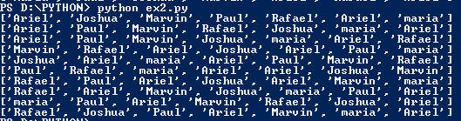

COPYING A LIST

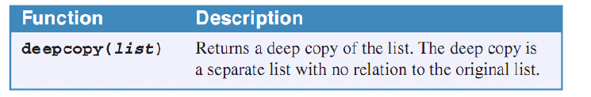

* Remember that list is a mutable type. If you assigned a variable of a list to another variable, then both variables refer to the same list object.
* The other variable is a *shallow copy* of the previous. Whatever operations applied to the list object through any of the variables can be seen on all variables with current references to the list object.
* To create a *deep copy* (preferably, a true new copy), use the copy.deepcopy() function. Import the copy module first.
* A *deep copy* is a separate object with no relation to the original object.

#Copying lists

import random

import copy

people = ["Ariel", "Joshua", "Marvin", "Paul", "Rafael", "Ariel", "maria"]

numbers = []

#Generate a list of numbers

for x in range(0,10):

numbers.append(random.randint(1,100))

#Using the copy.deepcopy() function

persons = people

print("The persons variable points to the same object that is being pointed by the people variable: ", persons)

print("If I did some operations to the persons variable, then it will be reflected with the people variable")

random.shuffle(persons)

print("This is the object of persons: ", persons)

print("This is the object of the people: ", people)

print("If I use deepcopy(), a true new copy will be created and it has no link to the original.")

persons = copy.deepcopy(people)

print("This is the object of the people: ", people)

print("This is the object of persons: ", persons)

print("If I did some operations to the persons variable, then it will not be reflected with the people variable")

random.shuffle(persons)

print("This is the object of the people: ", people)

print("This is the object of persons: ", persons)

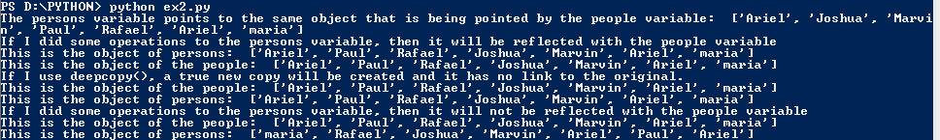

SLICING A LIST

* A list can be sliced using the notation: a_list[start:end:step].
* a_list[:] returns everything
* a_list[:4] returns items from the start to the index 3.
* a_list[4:] returns items from the index 4 to the end.
* a_list[::2] returns items from the start but stepping two indices at a time.
* a_list[::-1] returns all items but with the reverse order with a step of 1.
* Remember that the end argument is not included with the slicing.
* Slicing returns a new object. It does not slice the original one.

#Slicing a list

import random

import copy

people = ["Ariel", "Joshua", "Marvin", "Paul", "Rafael", "Ariel", "maria"]

numbers = []

#Generate a list of numbers

for x in range(0,10):

numbers.append(x)

print(numbers)

print("numbers[:] returns everything: ", numbers[:])

print("numbers[:6] returns all from start to 5: ", numbers[:6])

print("numbers[4:] returns 4 to 9: ", numbers[4:])

print("numbers[4:7] returns 4 to 6: ", numbers[4:7])

print("numbers[::2] returns all even numbers up to 8: ", numbers[::2])

print("numbers[1::2] returns all odd numbers from 1 to : ", numbers[1::2])

print("numbers[::-1] returns everything but in reversed order: ", numbers[::-1])

print("numbers[-2::-2] returns all even numbers but from 8 to 0: ", numbers[-2::-2])

print("numbers[-1::-2] returns all odd numbers but from 9 to 1: ", numbers[-1::-2])

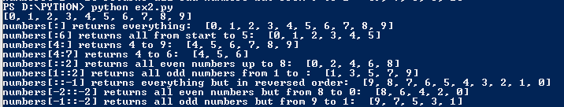

COMBINING LISTS

* To combine two or more lists, use the + or the += operators.
* The + operator just adds the two objects but without modifying the operand objects. It just returns an object of the combination of the lists.
* The += operator appends the operand to the original list. This is the same as putting another list to a list permanently.

#Combining lists

import random

import copy

people = ["Ariel", "Joshua", "Marvin", "Paul", "Rafael", "Ariel", "maria"]

numbers = []

#Generate a list of numbers

for x in range(0,10):

numbers.append(x)

print(numbers)

print(people)

print(numbers + people)

people += numbers

print(people)



TUPLES

* A tuple is a sequence that works much like a list.
* A tuple is immutable, thus it cannot be changed.
* To create a tuple, use the same procedure when creating a list but use () instead of [].
* To create a tuple with single item, use this tuple_var = (99,). It has one int item. Without the comma, the compiler will only create an int object.
* Tuples are more efficient than lists. Use them whenever there is an assurance that the collection won’t be changed. Think of them as constant items.

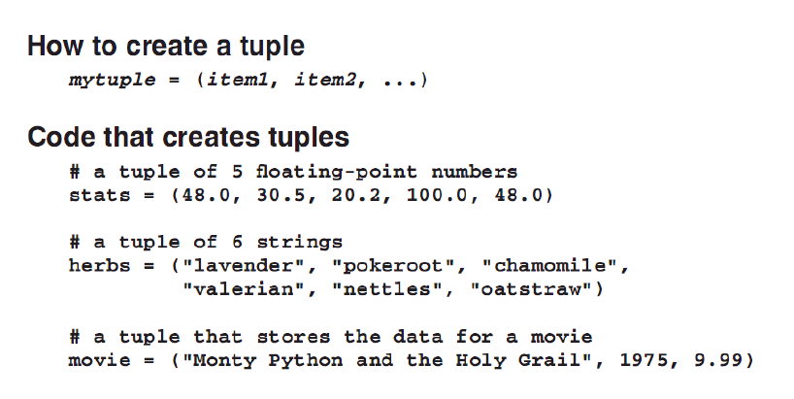

ACCESSING ITEMS IN A TUPLE

* To access an item in a tuple, use the bracket indices.
* The splicing techniques with the list can also be used for slicing tuples since they don’t really change the items. They only create a subset object.
* A tuple item cannot be changed. It can only be accessed.

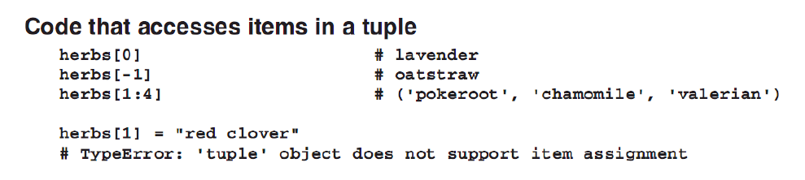

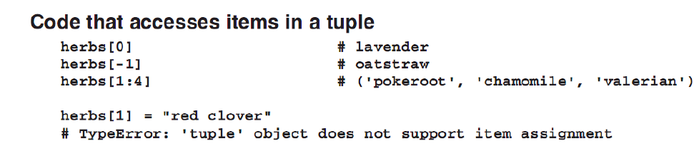

* Tuples can be unpacked. To unpack, var_1, var_2, var3 = tuple_var
* The tuple_var is a tuple with three items.
* At the end of the statement, the vars will have the values in order based on the tuple_var.
* This is the same mechanism when a function returns one or more values. var_1, var_2 = function(). This is a multiple assignment statement.

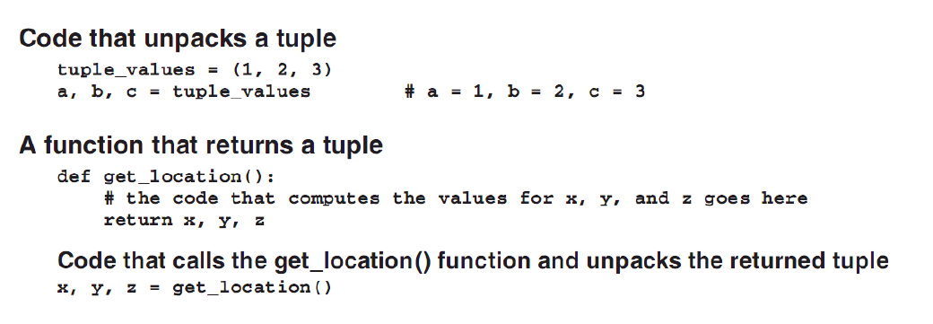

* NOTE: When creating tuples, make sure that all items are known. The items in a tuple cannot be changed.

Chapter 7. How to Work with File I/O

FILE I/O (INPUT AND OUTPUT)

* Python supports different file types.

GENERAL FILE TYPES SUPPORTED BY PYTHON

1. Text file – stores all of its data as characters and each line ends with a new line (\n) character.
   1. Comma-separated Values File (CSV) – a type of text file that stores multiple values in each line. Typically, it uses a comma to separate the values.
2. Binary file – can also store character data along with numeric data types. It’s any file that isn’t a text file. Basically, it contains data that doesn’t represent text. It could be audio, video, etc.. Data is continuous and not separated by the newline character.

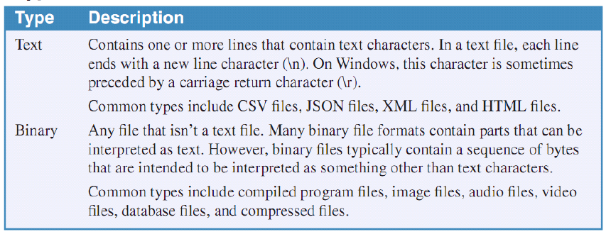

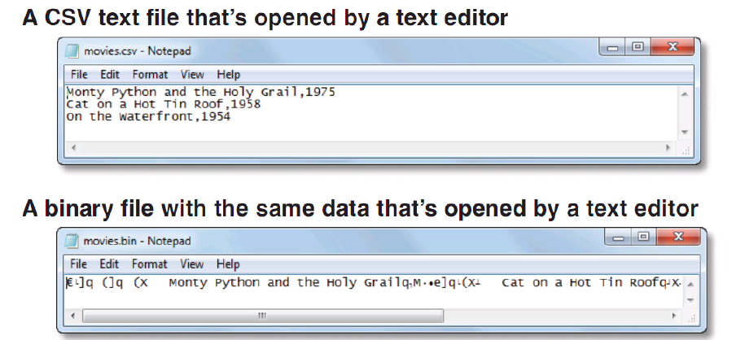

GENERAL STEPS IN WORKING WITH FILE IN PYTHON

1. Open the file.
2. Read or write (to) the file.
3. Close the file to free resource.

* When a program writes to a file, it saves the data in the main memory to the disk. When the program restarts, the data persists on the *persistent memory storage*.

OPENING AND CLOSING A FILE

* To open a file, a *file object* must be created first.
* Use the open() function to do this.

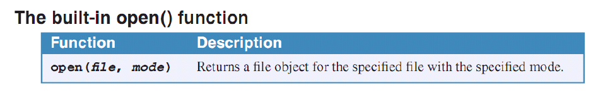

* The file parameter is the name of the file or the full path (can be relative). It must be a string. The compiler searches the present working directory for the file if only the filename is given. The mode is the reason for opening the file: read, write, etc.
* NOTE: The open() function is a built-in function.

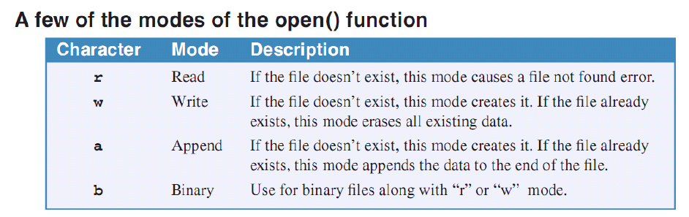

* The read mode is the default. The mode parameter in the open() function is a string also.
* The append mode is used when a data will be appended to the file to be opened.
* The main differences among the mode (except binary) is what they do when the file does not exists. For the read mode, a file not found error will occur while for the other two, the file will be created automatically.
* Remember, after working with a file, close it to free used resources.
* Use the close() function.

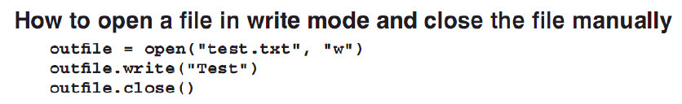

* NOTE: If an error happens after opening a file and before closing the file, the later closing of the file will not happen and the resources will not be released. Use the *with* statement.
* The *with* statement performs the opening and the processing of the file and then automatically closes the file after the processing even after an error occurs during the processing.
* Format:

with open(“file.txt”, “w”) as write_file:

write_file.write(“Hello world”)

* The file.txt will be opened or created if it does not exists. The string, “Hello world” will be written to it. If an exception happens, the file will still be closed.

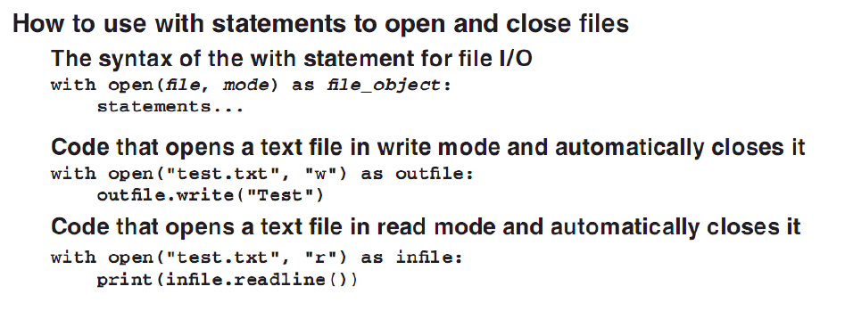

USING TEXT FILES

* When writing to a text file, use the write or append mode.
* Use the file_object.write(str) function to write something to the file.
* When writing to a file and using data types other than a string, convert the data to string first using the str() function.

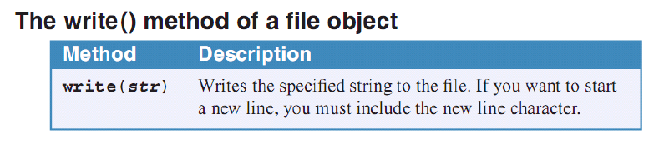

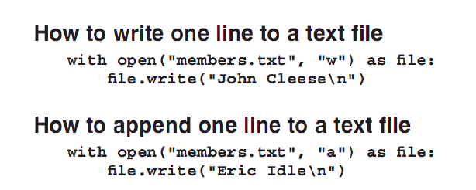

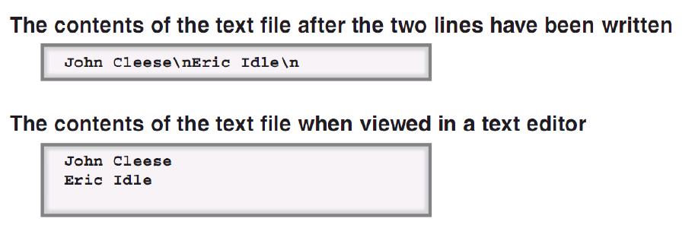

#Working with files. Writing a CSV file.

import random

def main():

create_csv("sample.csv",1000,10,0,100)

print("------->")

def create_csv(filename,lines,columns,min,max):

with open(filename, "a") as write_file:

for line in range(0,lines):

for value in range(0, columns):

write_file.write(str(random.randint(min,max)))

write_file.write(",")

write_file.write("\n")

if __name__ == "__main__":

main()

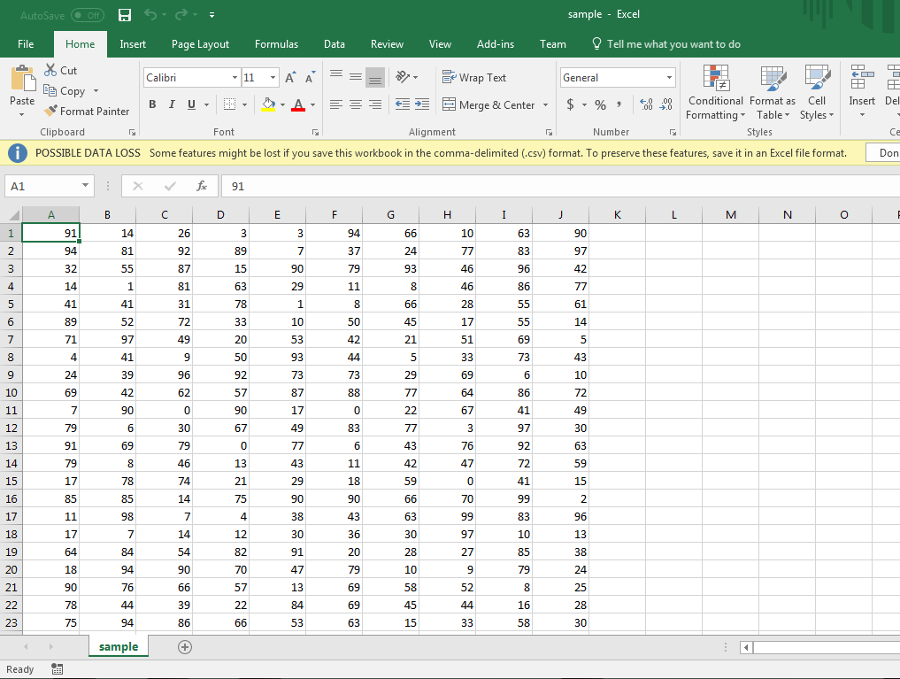



* To read a text file, use the read mode when opening a file.

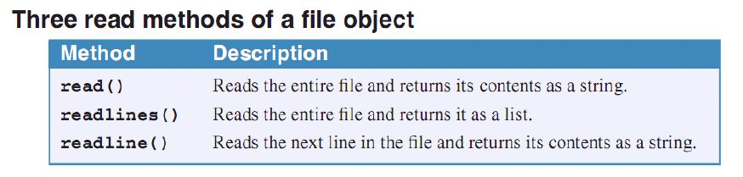

* The file_object.read() reads the whole file and return its contents as a string.
* The file_object.readlines() reads the entire file and returns it as a list.
* The file_object.readline() returns a line from the file. It reads a line until it reaches a new line.

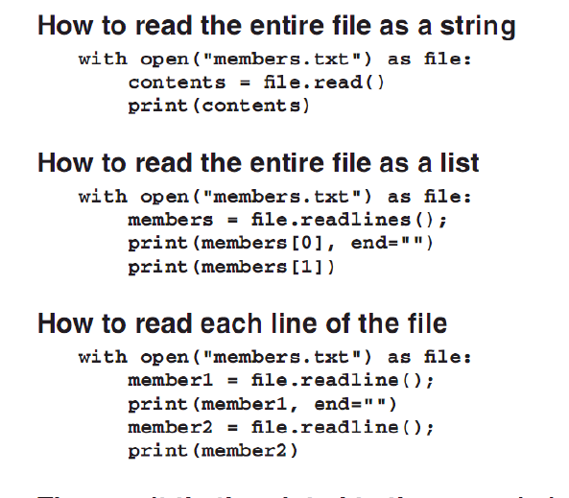

* The read mode is the default mode of the open() function.
* When using a For loop, you can directly read the lines without the file_object.readline() function.
* The file_object.readline() reads the lines one by one. It means that every line is copied to the main memory individually. This is not true for the file_object.read() and file_object.readlines() where all the contents of the file is copied to the main memory all at once.

PROCESSING LIST IN A TEXT FILE

* Read the file and replace the newline character with “” (effectively removing it). Use the str_variable.replace(what,with) function.

#Working with files. Writing a CSV file.

import random

def main():

create_csv("sample.csv",1000,10,0,100)

print("------->")

print(read_csv("sample.csv"))

def create_csv(filename,lines,columns,min,max):

with open(filename, "a") as write_file:

for line in range(0,lines):

for value in range(0, columns):

write_file.write(str(random.randint(min,max)))

write_file.write(",")

write_file.write("\n")

#Creates a list from the CSV file

def read_csv(filename):

read_list = []

with open(filename) as read_file:

for line in read_file:

read_list.append(line.replace("\n",""))

return read_list

if __name__ == "__main__":

main()



(Notice that the items in the list are single lines from the file with the newline character gone.)

USING CSV FILES

* A line in a CSV file contains many data separated with commas.
* Lines is separated with the newline character.
* Each line is called a *row* or *record*. (Just like in database)
* Each row contains one or more *columns* or *fields*.
* There is a CSV module for Python.

WRITING A CSV FILE

* To create a CSV file, import the csv module.
* A CSV writer object must be created with the filename of the CSV file to be created as an argument.
* Use the *with* statement with the write or append mode.

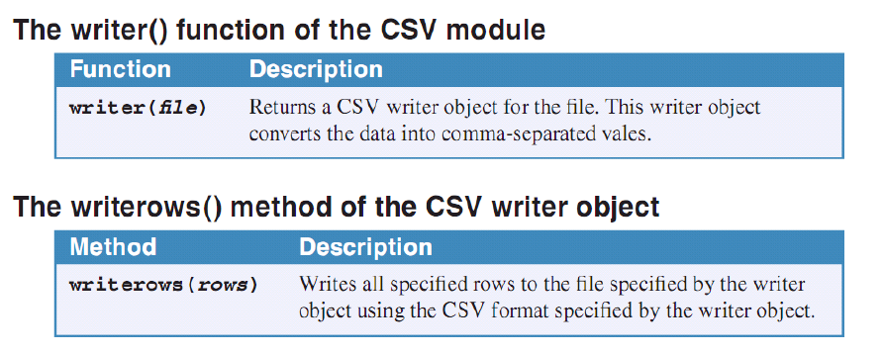

Steps:

1. Open the file in write or append mode using the open(filename, mode, newline = “”). Use the newline argument to enable *universal newline mode*/. This allows the csv module to read and write new lines correctly for all operating systems.
2. Create a CSV writer object. csv_writer = csv.writer(file_object). The file_object is a reference to the file.
3. Use the csv_writer.writerows(rows) to write rows to the file. NOTE: the rows variable contains all the rows to be written.

* Create the list of rows first before writing. The writing is the end part.

#Working with a CSV file

import csv

filename = "sample2.csv"

#Note that every item in the list must be a string

row = [["Ariel", "Catli", "22", "774 Real St., Intramuros, Manila"],["Joshua", "Viterbo", 23, "774 Real St., Intramuros, Manila"]]

with open(filename, "w", newline="") as file:

csv_writer = csv.writer(file)

csv_writer.writerows(row)

#Note that the csv_writer.writerows() function only work with a whole list

#meaning that every row must be in a single list.

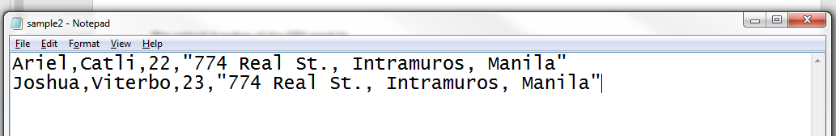

* NOTE: The csv_writer.writerows() function only accepts one list with all the rows in it. That’s why it was called write*rows*().
* The csv module wraps field values with special characters. Notice the address part.

READING A CSV FILE

* To read a CSV file, import the csv module.
* Open the file as read mode using a *with* statement and create a file object.
* Create a csv reader object. csv_reader = csv.reader(file_object)
* Get the lines of the reader object using a for loop. Reference each row items using indexing. Basically, the reader creates a tuple from these rows.

#Working with a CSV file

import csv

filename = "sample2.csv"

#Note that every item in the list must be a string

row = [["Ariel", "Catli", "22", "774 Real St., Intramuros, Manila"],["Joshua", "Viterbo", 23, "774 Real St., Intramuros, Manila"]]

with open(filename, "w", newline="") as file:

csv_writer = csv.writer(file)

csv_writer.writerows(row)

#Note that the csv_writer.writerows() function only work with a whole list

#meaning that every rows must be in a single list.

with open(filename) as read_file:

csv_reader = csv.reader(read_file)

for line in csv_reader:

print(f"Name: {line[0]} {line[1]}\nAge: {line[2]}\nAddress: {line[3]}\n\n")

#Reference each line using indexing

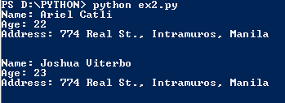

READING CSV WITH OTHER FORMATS

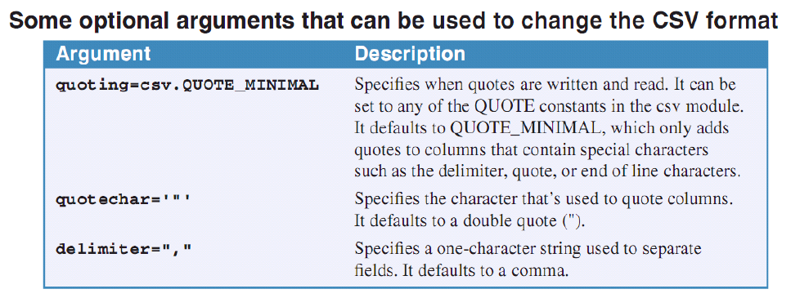

* csv_obj(file_object, quoting=csv.QUOTE_MINIMAL) creates a csv reader/writer object that specifies when quotes are written and read. The default is the QUOTE_MINIMAL.
* The csv_obj(file_obj, quotechar=’”’) specifies what character to use a marker.
* The csv_obj(file_obj, delimiter=”,”) sets the delimiter of the csv file.
* Use these arguments for the writer and reader objects to change the format of the CSV files.

USING BINARY FILES

* The *pickle* module is used to work with binary files in Python. It is a standard module.
* It automates the process of storing an object in a binary file.
* To work with binary files, import pickle module.
* No objects will be created.
* Remember, a binary file store an object.

WRITING TO BINARY FILES

1. Create the list/object to be written to a binary file.
2. Open/Create the binary file with the write binary (wb) or append binary (ab) mode.
3. Use the pickle.dump(object_to_save, binary_file).

* NOTE: The process of saving an object to a binary file is called *serializing*. In Python, it is called *pickling*. (Maybe due to the module’s name?)

#Working with a binary file

import pickle

filename = "binary_file.bin"

#Note that every item in the list must be a string

row = [["Ariel", "Catli", "22", "774 Real St., Intramuros, Manila"],["Joshua", "Viterbo", 23, "774 Real St., Intramuros, Manila"]]

#Dumping to a binary file

#Or use "ab" mode

with open(filename, "wb") as write_file:

pickle.dump(row,write_file)

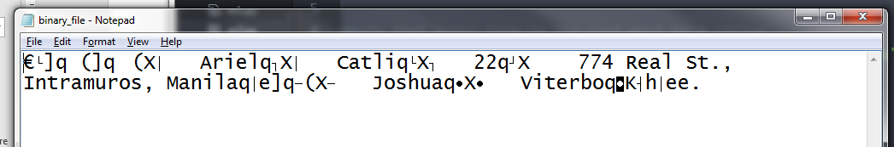

READING A BINARY FILE

1. Open the file object in a reading binary mode (rb) which reads the binary file.
2. Create a list to store the file’s contents.
3. Use the pickle.load() function. var = picke.load(binary_file)

#Working with a binary file

import pickle

filename = "binary_file.bin"

#Note that every item in the list must be a string

row = [["Ariel", "Catli", "22", "774 Real St., Intramuros, Manila"],["Joshua", "Viterbo", 23, "774 Real St., Intramuros, Manila"]]

#Dumping to a binary file

#Or use "ab" mode

with open(filename, "wb") as write_file:

pickle.dump(row,write_file)

#Loading from a binary file

#Use the read binary mode (rb)

with open(filename, "rb") as read_file:

var = pickle.load(read_file)

print(var)



Chapter 8. How to Handle Exceptions

HANDLING A SINGLE EXCEPTION

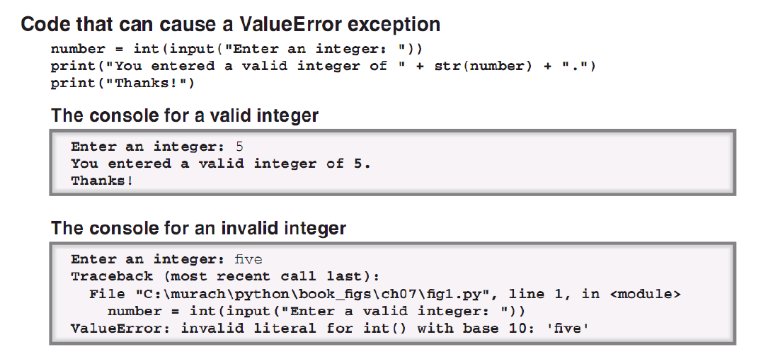

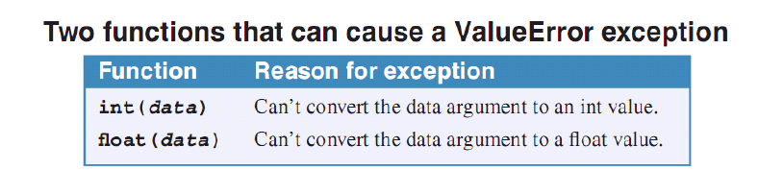

* An exception is thrown when there is an error. During this time, a message is displayed like when a user input a string data to an int input.
* Exception handling – the process where exceptions are caught and resolved so that the program won’t stop executing.
* Use *try* statement to handle one exception.
* The *try* clause contains the code that might throw an exception. Then code the *except* cause after the *try* clause that will be executed if an exception is thrown.

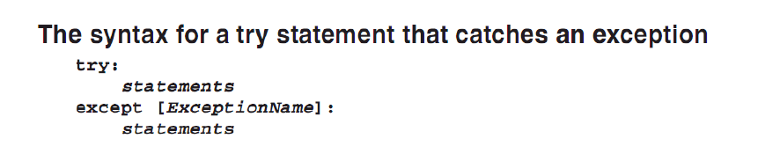

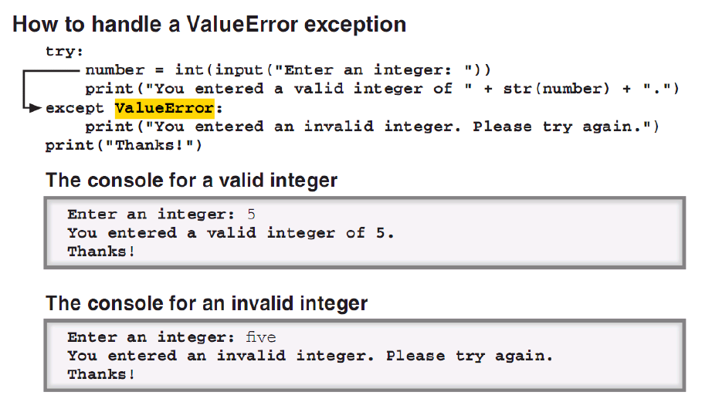

#Handling exceptions

number = 0

print("Enter a number and let us square it: ")

#If a ValueError exception is thrown, then the except clause will be

#executed.

try:

number = int(input())

number *= number

print(number)

#This is the equivalence of the catch clause in other

#programming languages.

#The ValueError is optional. Without it, all kinds of

#exceptions will be caught.

except ValueError:

print("Oh. It must be a number, silly!")

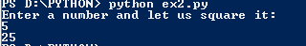

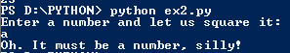

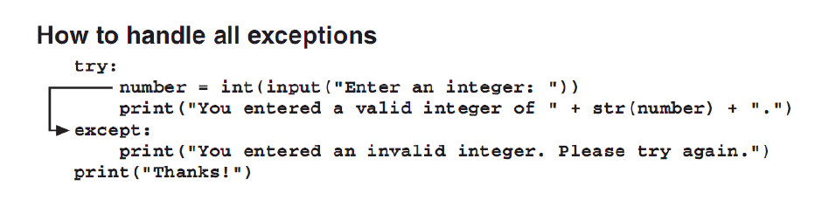

* Data validation – the process of making sure that the input has the correct type of data for processing.

HANDLING MULTIPLE EXCEPTIONS

* It makes sense to provide different exception handling codes for possible types of exceptions.
* The Exception class is the most general type of exception and the parent class of the child OSError and ValueError classes which define more specific exceptions.
* The OSError is the parent class of FileExistsError and FileNotFoundError.

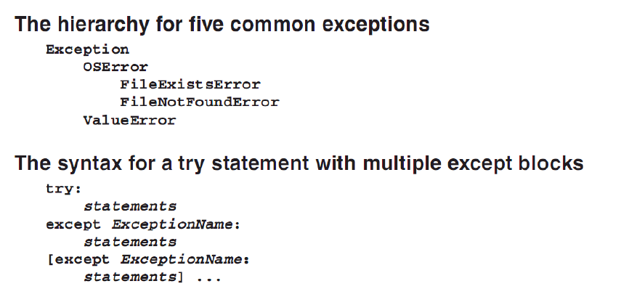

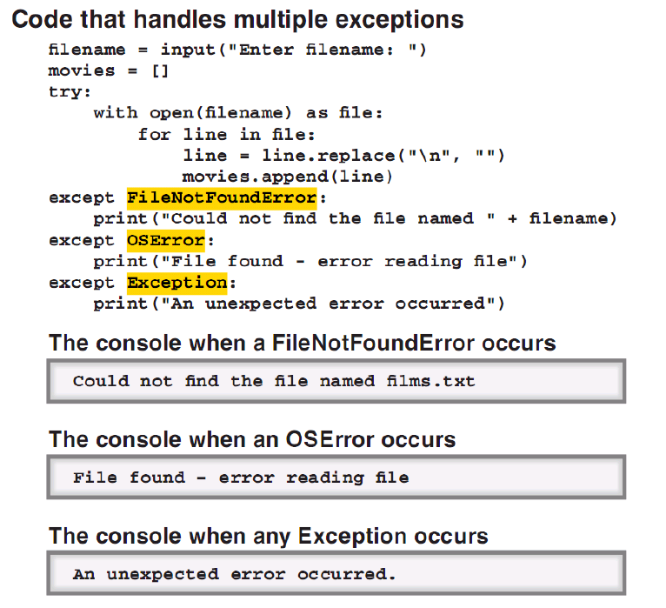

* NOTE: Catch the exceptions from more specific to general. If the other way around is done, then the exception handling is not specific.

GETTING INFORMATION FROM AN EXCEPTION OBJECT

* The exception object uses the sys.exit() function to terminate the program.

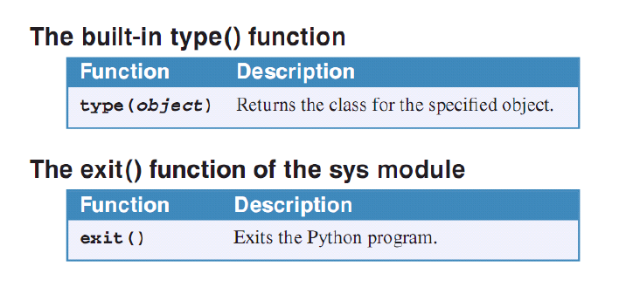

* Use the built-in function type(object) to get the class of the object.
* Use the keyword *as* to ‘alias’ a long exception.
* Use the print() function to print the exception object’s message.
* Handle all possible scenarios.

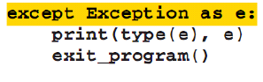

* Use the code above to provide a general exception handling.

USING A FINALLY CLAUSE

* The *finally* clause is executed after the *try* or the *except* clause is executed.
* Typically, it was used to free used resources.

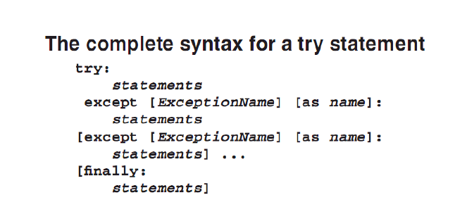

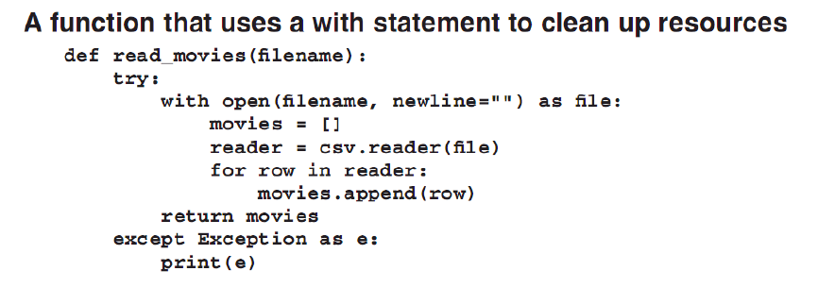

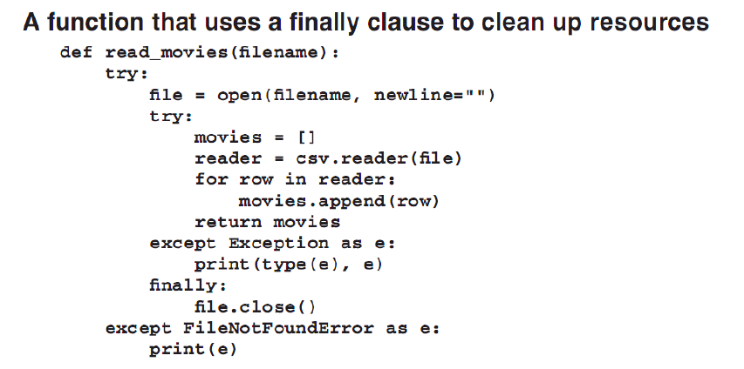

RAISING AN EXCEPTION

* To raise an exception means forcing an exception to occur.
* An exception may be raised if the argument that is passed to a function is wrong.
* An exception can also be raised for chained exceptions.
* To raise an exception, use the *raise* statement.

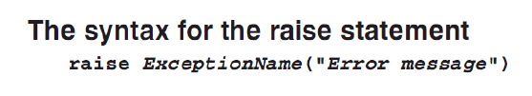

#Raising an exception

raise ValueError("This is an example of a raised exception.")

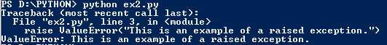

* NOTE: The exception name must be an Exception object.

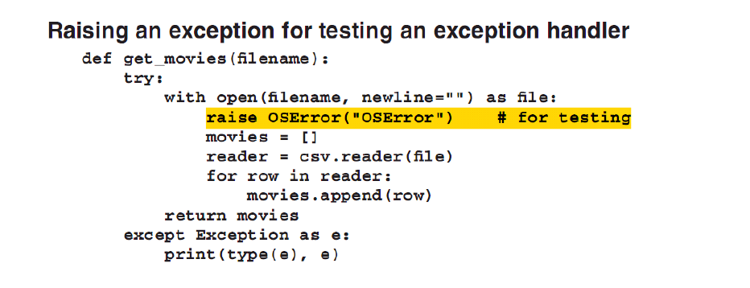

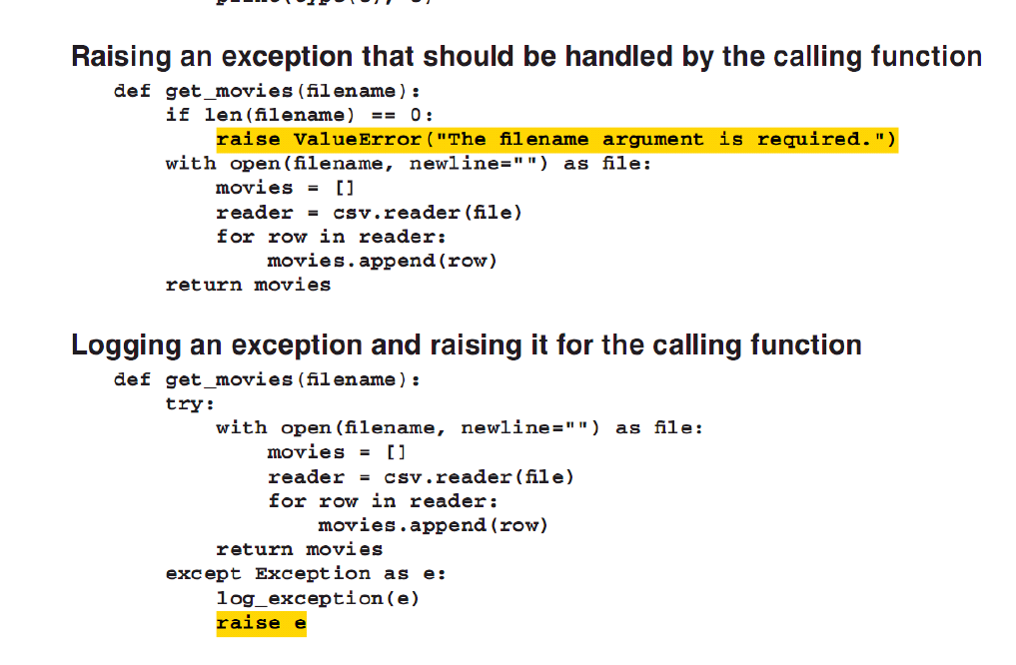

Chapter 9. How to Work with Numbers

* The int data type uses 32 bits or 4 bytes of storage to store integers.
* The float data type use 64 bits or 8 bytes of storage to store floating-point numbers.
* However, float type can only use 16 significant digits to store the number.
* For floating point numbers, use the scientific notation: 2.3e[+]21. This is equivalent to 2.3 raised to 21.
* Floating point numbers are approximate only and not exact values.
* Integers are exact values.
* To fix the inaccuracy of the floating point numbers, round them up to two decimals places.

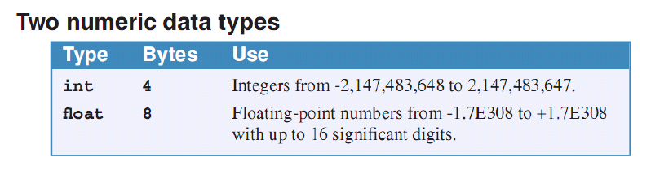

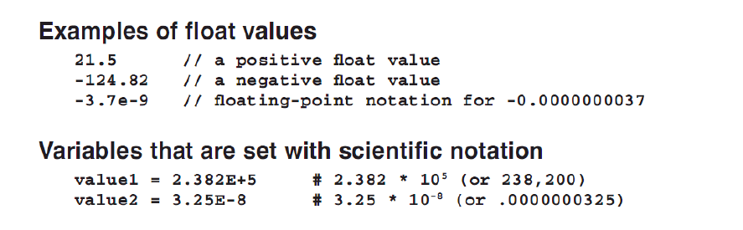

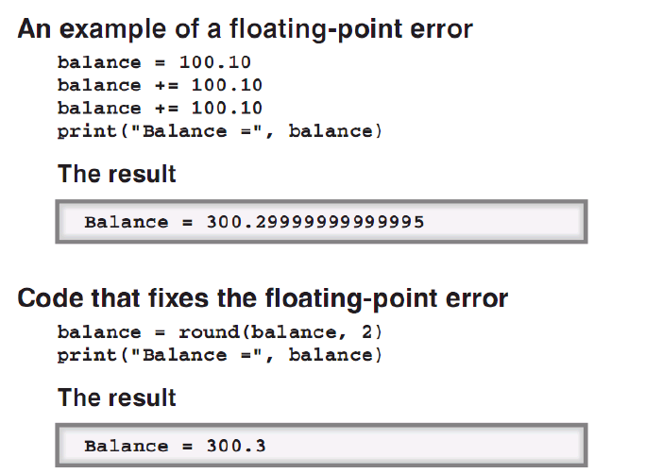

USING THE MATH MODULE

* Python provides a standard math module.
* Import the math module first.
* import math [as new_namespace]

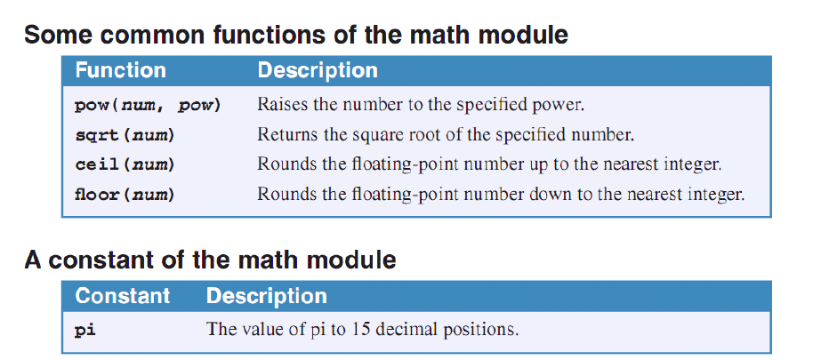

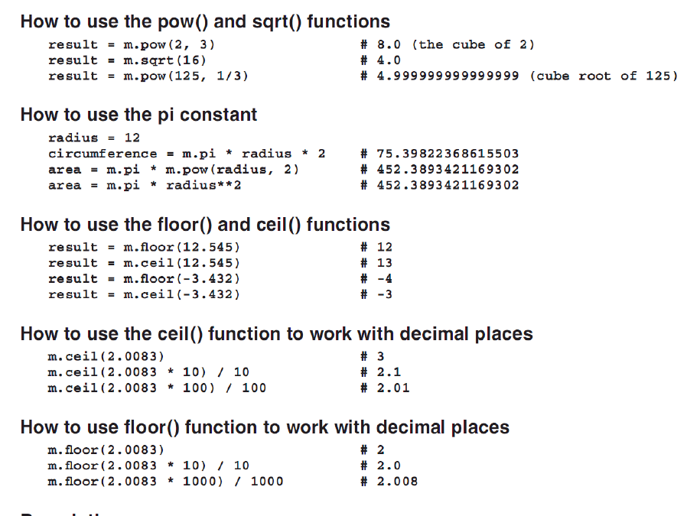

FORMATTING NUMBERS

* The syntax for formatting numbers is shown below.

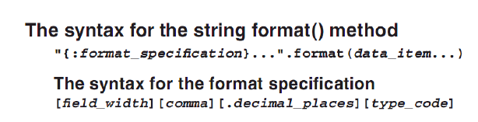

* The format of the format specification is {:field_width.number_of_decimal_places} for floating point numbers.
* For the integers,

{:field_width.d}

* To convert to scientific notation, {:.decimal_placesE} (add e).
* To get convert to percentage, {:0.decimal_places%} (add %).

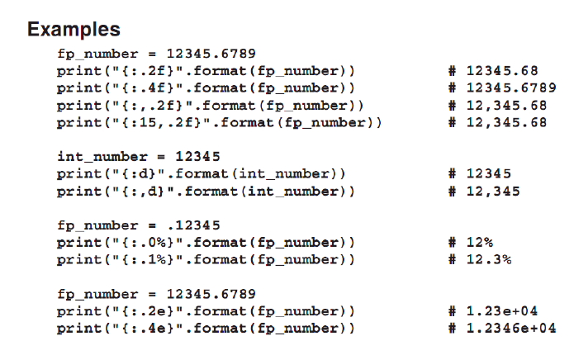

TO ALIGN FIELDS

* Use the field width and the > or < for the orientation to be right or left.

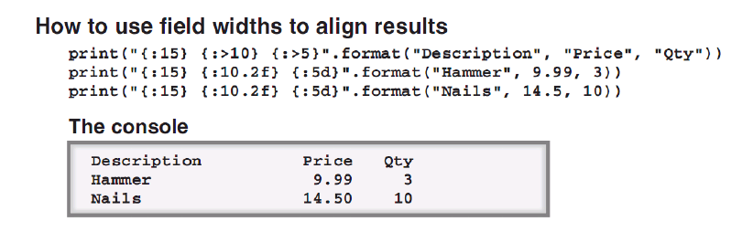

(UNFINISHED)

Chapter 14. How to Define and Use Your Own Classes

Class – allows the grouping of related variables (attributes) and functions (methods) into data structures called *objects*. This is the foundation of object-oriented programming. A class is a template or a blueprint in which one or more objects can be created. It has variable called *attributes* and functions which are *methods*.

Object – an instance of a class. Once an object is created from a class, the object has an *identity* (a unique address), *state* (the stored data of the variables) and *behavior* (the method that it contains). As a program runs, an object’s state may change.

Instantiation – the process of creating an object from a class.__

Unified Model Language (UML) – a modeling language that is the industry standard for working with all object-oriented programming languages.

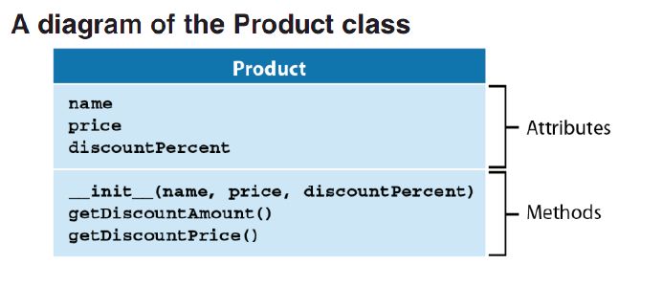

* Attributes are member variables.
* Methods are member functions.
* __init___() is a special method that creates an object from the class and initializes its attributes. It is the constructor.

|  |  |  |
| --- | --- | --- |
|  | CLASS | OBJECT |
| Variables | Attributes | State |
| Functions | Methods | Behavior |

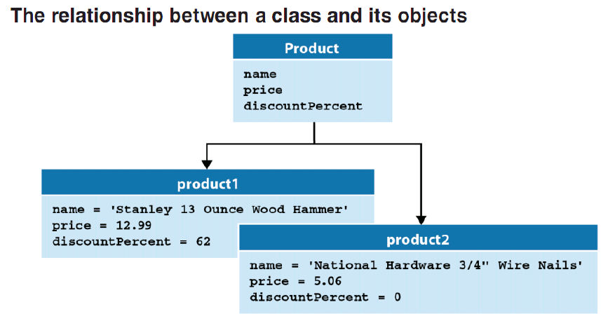

DEFINING A CLASS

* Format: class Class_name:
* It’s common to start user-defined class names with an uppercase letter.
* The __init__() method is a constructor which is automatically called whenever an object is created from a class. The constructor can run any code for initialization and not just attribute initialization.
* A class can only contain one constructor.
* When coding a constructor, code parameters that supply the initial values for the attributes of the object. It is also recommended to use *named parameters*.
* All methods of the class must have a parameter for the object itself. This is required. Use the *self* variable.
* The *self* variable parameter is used so that methods can access the same object from within the class. It will always be used first in the __init__() so that while the object lives, it has accept to itself through the *self* variable.

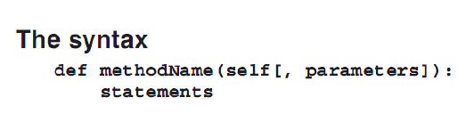

* The *self* parameter in a class is not visible to users of the class. Don’t supply any parameter to it.
* Always qualify the attributes and the methods with object itself: self.attribute or self.method

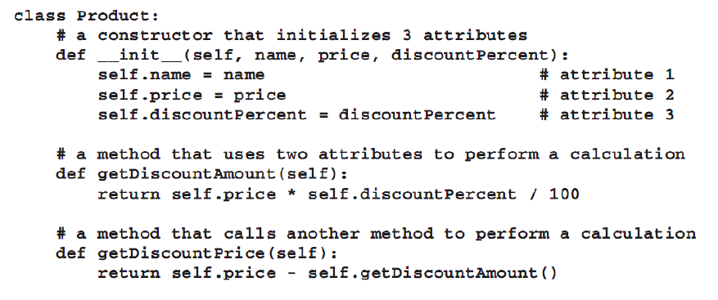

STEPS:

1. Declare a class: class Classname:
2. Define the constructor: def __init__(self, parameter_list):

self.attribute1 = something

1. Define the methods: def method1(self):

* REMEMBER: Always include the object itself in all the methods of the class using the *self*. The *self* variable may vary but this is the convention.
* All the members of the class are default to be public.

CREATING AN OBJECT FROM A CLASS

* Import the class first. A good way to import is using the *from* variation. After importing using this method, the class will not be qualified anymore by the module name.

STEPS:

1. Import the class using the *from* variation.
2. Create an object from the class: obj = Class(“some data initialization”).

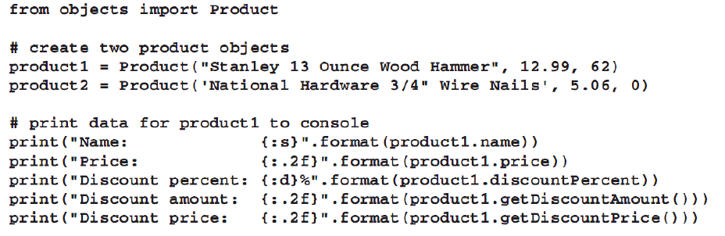

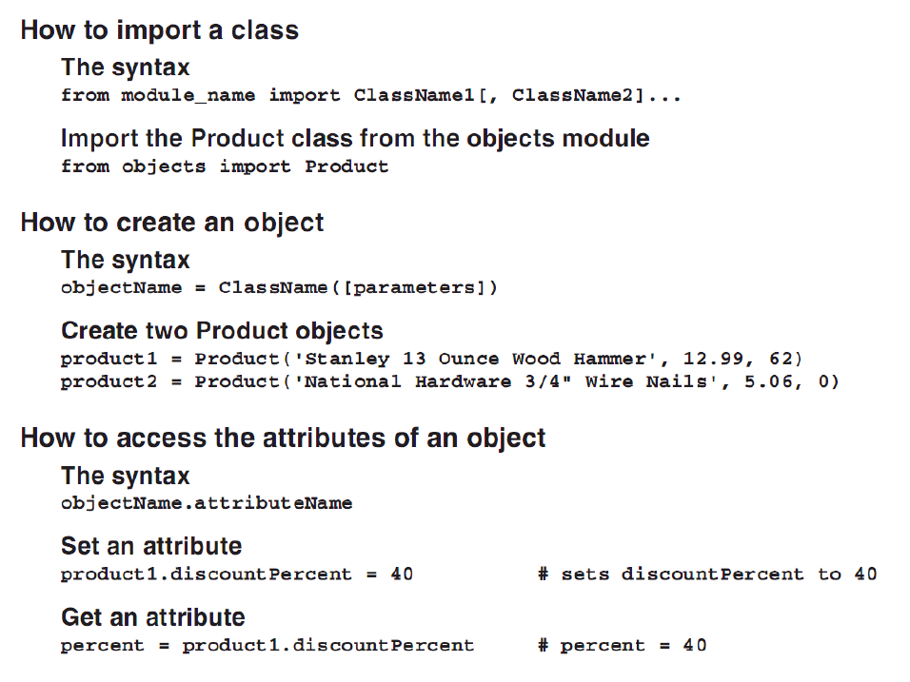

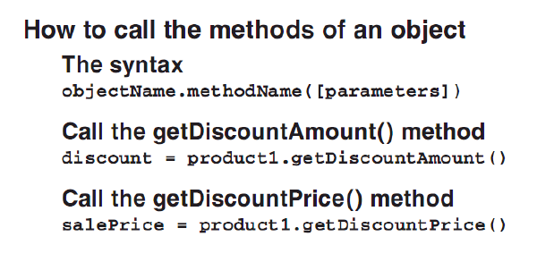

* Use the member access operator (.) to access the state and the behaviors.

EXAMPLE

**a. Client file using the School module (School.py),**

from School import *

science_classroom = Class_room("Ariel Catli Room", "000")

science_classroom.assign_assistant(Assistant("Maria Leonora Teresa",science_classroom))

science_classroom.assign_subject(Subject("Science",40))

science_classroom.status()

**b. School module (School.py)**

# -*- coding: utf-8 -*-

"""

Created on Mon Oct 30 11:05:44 2017

@author: Ariel Domingo Catli

"""

#This is the module

class Class_room:

def __init__(self, name, number):

self.name = name

self.number = number

def assign_assistant(self, assistant):

self.assistant = assistant

def assign_subject(self, subject):

self.subject = subject

def status(self):

print(f"Classroom Number: {self.number}",

f"Classroom Name: {self.name}",

f"Classroom Assistant: {self.assistant.name}",

f"Assigned Subject: {self.subject.name}",

f"Enrolled: {self.subject.enrolled}",sep="\n")

class Assistant:

def __init__(self, name, assigned_room):

self.name = name

self.assigned_room = assigned_room

def assign_room(self, room):

self.room = room

class Subject:

def __init__(self, name, num_enrolled):

self.name = name

self.enrolled = num_enrolled

OUTPUT:

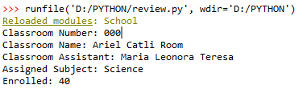

OBJECT COMPOSITION

Object Composition – the process of combining simple objects into more complex data structures.

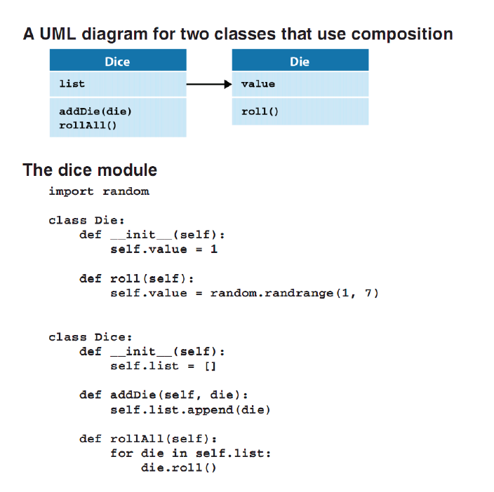

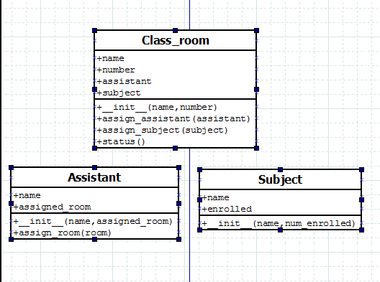

ENCAPSULATION

Encapsulation – prevents direct access to the data attributes of an object. This process hides the object’s data from the calling code. It is also known as *data-hiding*.

* To hide data, use private attributes and then code public methods that access these data properly.
* To code private attributes or methods, the names must be preceded by two underscores (__). Format: __var, __method

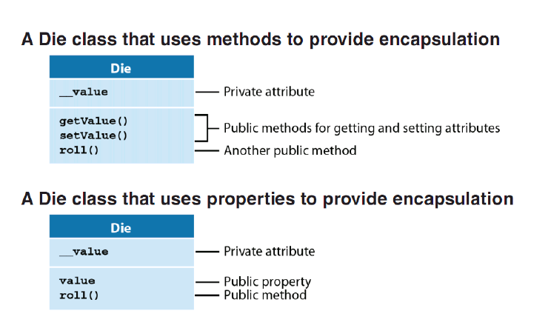

Interface – allows a programmer to use an object without understanding its internal code. If the interface of an object remains the same, a programmer can change the internal code for the object without needing to change any of the code that uses the object.

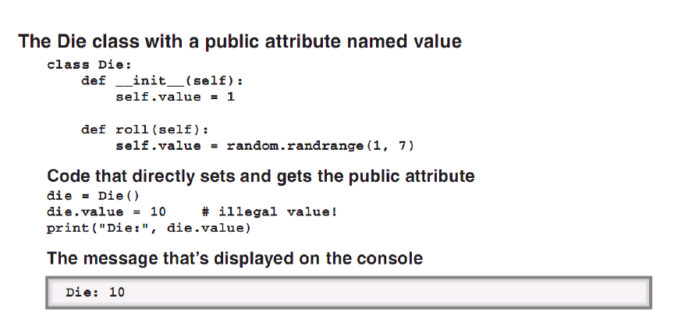

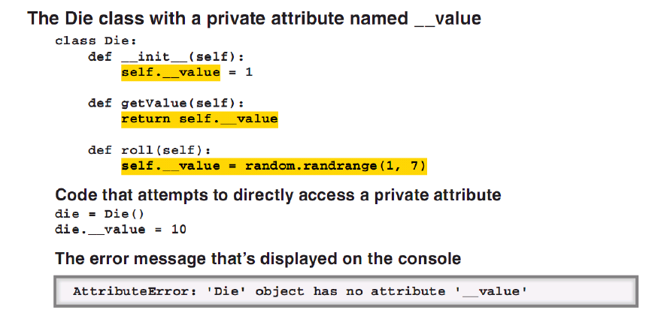

ACCESSORS AND MUTATORS

Getters/Accessors – methods that access private attributes.

Setters/Mutators – methods that modify private attributes.

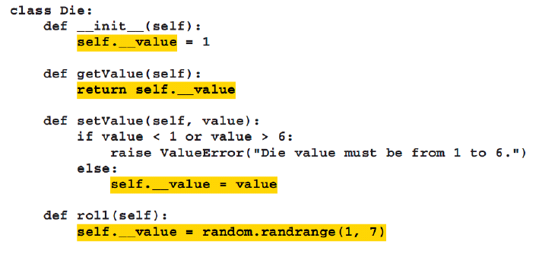

* By convention, getters and setters’ names begin with get- and set-.
* Format: def getValue(self):

return something

* Format: def setValue(self, new_value):

self.__private_var = new_value

EXAMPLE:

**a. Client File**

# -*- coding: utf-8 -*-

"""

Created on Mon Oct 30 11:05:44 2017

@author: Ariel Domingo Catli

"""

import random

#This is the module

class Class_room:

def __init__(self, name, number, key_length):

self.name = name

self.number = number

self.__door_key = self.__generate_door_key(key_length)

def assign_assistant(self, assistant):

self.assistant = assistant

def assign_subject(self, subject):

self.subject = subject

def status(self):

print(f"Classroom Number: {self.number}",

f"Classroom Name: {self.name}",

f"Classroom Assistant: {self.assistant.name}",

f"Assigned Subject: {self.subject.name}",

f"Enrolled: {self.subject.enrolled}",

f"Door Key: {self.get_key()}",sep="\n")

def __generate_door_key(self, key_length):

allowed_chars = ['1','2','4','d','#','%','@']

key = ""

for i in range(0,10):

key += random.choice(allowed_chars)

return key

def get_key(self):

return self.__door_key

class Assistant:

def __init__(self, name, assigned_room):

self.name = name

self.assigned_room = assigned_room

def assign_room(self, room):

self.room = room

class Subject:

def __init__(self, name, num_enrolled):

self.name = name

self.enrolled = num_enrolled

**b. School module**

# -*- coding: utf-8 -*-

"""

Created on Mon Oct 30 11:05:44 2017

@author: Ariel Domingo Catli

"""

import random

#This is the module

class Class_room:

def __init__(self, name, number, key_length):

self.name = name

self.number = number

self.__door_key = self.__generate_door_key(key_length)

def assign_assistant(self, assistant):

self.assistant = assistant

def assign_subject(self, subject):

self.subject = subject

def status(self):

print(f"Classroom Number: {self.number}",

f"Classroom Name: {self.name}",

f"Classroom Assistant: {self.assistant.name}",

f"Assigned Subject: {self.subject.name}",

f"Enrolled: {self.subject.enrolled}",

f"Door Key: {self.get_key()}",sep="\n")

def __generate_door_key(self, key_length):

allowed_chars = ['1','2','4','d','#','%','@']

key = ""

for i in range(0,10):

key += random.choice(allowed_chars)

return key

def get_key(self):

return self.__door_key

class Assistant:

def __init__(self, name, assigned_room):

self.name = name

self.assigned_room = assigned_room

def assign_room(self, room):

self.room = room

class Subject:

def __init__(self, name, num_enrolled):

self.name = name

self.enrolled = num_enrolled

USING PROPERTIES

Properties – special methods that are used to access hidden attributes. To create a property, use *annotations*.

Getter Property – a property that gets the value of the attribute.

Setter Property – a property that sets the value of the attribute.

STEPS:

1. Code the block that uses a private attribute.

def __init__(self, something):

self.__something = something

1. If needed, code the getter by:

@property

def something(self):

return self.__something

1. If needed, code the setter by:

@something.setter

def something(self, something):

self.__something = something

* REMEMBER: The properties have the same name as the private attribute.
* It is better to do data validation on the setter property.
* REMEMBER: Getter is @property and Setter is @priv_attr.setter
* REMEMBER: When calling a getter, treat it like the private attribute itself. The getter acts like an attribute and not a method. Thus, call it just like an attribute.
* REMEMBER: A setter cannot be used without a getter, but a getter can be used without a setter. The @private_atr.setter needs the @property

EXAMPLE:

**a. Client File**

from School import *

science_classroom = Class_room("Ariel Catli Room", "000", 20)

science_classroom.assistant = Assistant("Maria Leonora Teresa",science_classroom)

science_classroom.assign_subject(Subject("Science",40))

science_classroom.status()

science_classroom.assistant = Assistant("Lady Ada Byron",science_classroom)

science_classroom.status()

**b. School module**

# -*- coding: utf-8 -*-

"""

Created on Mon Oct 30 11:05:44 2017

@author: Ariel Domingo Catli

"""

import random

#This is the module

class Class_room:

def __init__(self, name, number, key_length):

self.name = name

self.number = number

self.__door_key = self.__generate_door_key(key_length)

self.__assistant = Assistant("N/A", "N/A")

@property

def assistant(self):

return self.__assistant

@assistant.setter

def assistant(self, assistant):

self.__assistant = assistant

def assign_subject(self, subject):

self.subject = subject

def status(self):

print(f"Classroom Number: {self.number}",

f"Classroom Name: {self.name}",

f"Classroom Assistant: {self.assistant.name}",

f"Assigned Subject: {self.subject.name}",

f"Enrolled: {self.subject.enrolled}",

f"Door Key: {self.door_key}",sep="\n")

def __generate_door_key(self, key_length):

allowed_chars = ['1','2','4','d','#','%','@']

key = ""

for i in range(0,10):

key += random.choice(allowed_chars)

return key

@property

def door_key(self):

return self.__door_key

class Assistant:

def __init__(self, name, assigned_room):

self.name = name

self.assigned_room = assigned_room

def assign_room(self, room):

self.room = room

class Subject:

def __init__(self, name, num_enrolled):

self.name = name

self.enrolled = num_enrolled

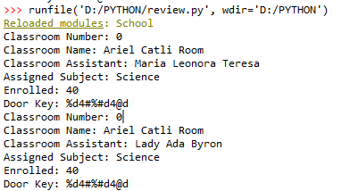

* NOTE: If a mutable attribute is returned, the calling code can change the attribute directly. One way to encapsulate a mutable attribute is to convert the mutable attribute to an immutable object (such as a tuple) before returning it.

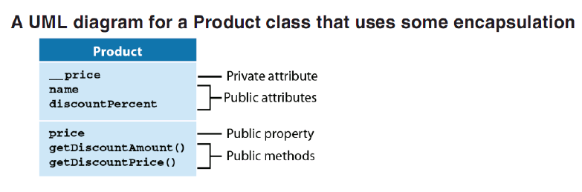

* The setter can be called on the __init__() function to initialize the private variable.
* NOTE: Use the setter to initialize variable with data validation. There is no need to declare private variables in the __init__() method. Just use properties.

**a. Client file**

from School import *

science_classroom = Class_room("Ariel Catli Room", 0, 20)

science_classroom.assistant = Assistant("Maria Leonora Teresa",science_classroom)

science_classroom.assign_subject(Subject("Science",40))

science_classroom.status()

science_classroom.assistant = Assistant("Lady Ada Byron",science_classroom)

science_classroom.status()

**b. School module**

# -*- coding: utf-8 -*-

"""

Created on Mon Oct 30 11:05:44 2017

@author: Ariel Domingo Catli

"""

import random

#This is the module

class Class_room:

def __init__(self, name, number, key_length):

self.name = name

self.number = number

self.door_key = self.__generate_door_key(key_length)

self.assistant = Assistant("N/A", "N/A")

def assign_subject(self, subject):

self.subject = subject

def status(self):

print(f"Classroom Number: {self.number}",

f"Classroom Name: {self.name}",

f"Classroom Assistant: {self.assistant.name}",

f"Assigned Subject: {self.subject.name}",

f"Enrolled: {self.subject.enrolled}",

f"Door Key: {self.door_key}",sep="\n")

def __generate_door_key(self, key_length):

allowed_chars = ['1','2','4','d','#','%','@']

key = ""

for i in range(0,10):

key += random.choice(allowed_chars)

return key

@property

def door_key(self):

return self.__door_key

@door_key.setter

def door_key(self, key):

self.__door_key = key

@property

def number(self):

return self.__number

@number.setter

def number(self, number):

if(number<=1000):

self.__number = number

else:

print("The room number should be equal to or below 1000.")

self.__number = "N/A"

@property

def name(self):

return self.__name

@name.setter

def name(self, name):

self.__name = name

@property

def assistant(self):

return self.__assistant

@assistant.setter

def assistant(self, assistant):

self.__assistant = assistant

class Assistant:

def __init__(self, name, assigned_room):

self.name = name

self.assigned_room = assigned_room

def assign_room(self, room):

self.room = room

class Subject:

def __init__(self, name, num_enrolled):

self.name = name

self.enrolled = num_enrolled

Chapter 15. How to Work with Inheritance

Inheritance – allows the creation of a new class based on an existing class. In inheritance, the subclass (derived or child class) inherits the public attributes and methods of a superclass (base or parent class). Then when an object is instantiated from the subclass, the object uses these attributes and methods.

Overriding – the subclass can change the way the attributes and methods of the superclass work.

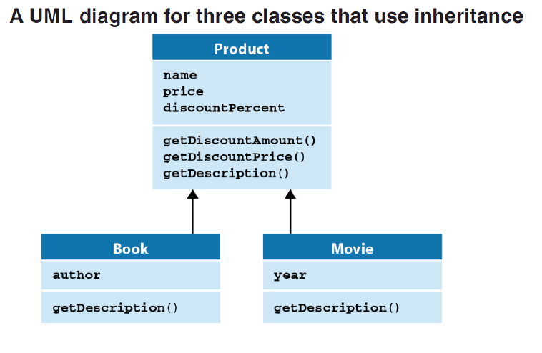

* The Book and the Movie classes are subclasses of the Product class.

DEFINING A SUBCLASS

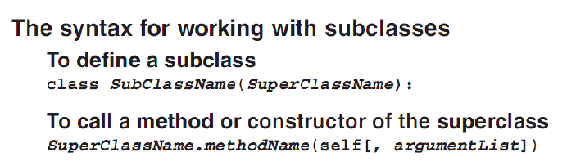

* The subclass constructor can call the superclass constructor to reuse code. Format: Parent.__init__(parameter), then add the new code of the new constructor.

EXAMPLE:

**a. Client file**

from School import *

print("\n<---CREATING A NEW ROOM---->")

science_classroom = Class_room("Ariel Catli Room", 0, 20, "Prof. Horacio Delevine")

science_classroom.assistant = Assistant("Maria Leonora Teresa",science_classroom)

science_classroom.assign_subject(Subject("Science",40))

science_classroom.status()

print("\n<----ASSIGNING A NEW ASSISTANT---->")

science_classroom.assistant = Assistant("Lady Ada Byron",science_classroom)

science_classroom.status()

print("\n<---CREATING A NEW ROOM---->")

faculty_room = Room("The Faculty Room", 25, 30)

faculty_room.assistant = Assistant("Julia Childs", faculty_room)

faculty_room.status()

**b. School module**

# -*- coding: utf-8 -*-

"""

Created on Mon Oct 30 11:05:44 2017

@author: Ariel Domingo Catli

"""

import random

#This is the module

class Room:

def __init__(self, name, number, key_length):

self.name = name

self.number = number

self.door_key = self.__generate_door_key(key_length)

self.assistant = Assistant("N/A", "N/A")

def status(self):

print(f"Room Number: {self.number}",

f"Room Name: {self.name}",

f"Assistant: {self.assistant.name}",

f"Door Key: {self.door_key}",sep="\n")

def __generate_door_key(self, key_length):

allowed_chars = ['1','2','4','d','#','%','@']

key = ""

for i in range(0,10):

key += random.choice(allowed_chars)

return key

@property

def door_key(self):

return self.__door_key

@door_key.setter

def door_key(self, key):

self.__door_key = key

@property

def number(self):

return self.__number

@number.setter

def number(self, number):

if(number<=1000):

self.__number = number

else:

print("The room number should be equal to or below 1000.")

self.__number = "N/A"

@property

def name(self):

return self.__name

@name.setter

def name(self, name):

self.__name = name

@property

def assistant(self):

return self.__assistant

@assistant.setter

def assistant(self, assistant):

self.__assistant = assistant

class Class_room(Room):

def __init__(self, name, number, key_length, assigned_professor):

Room.__init__(self, name, number, key_length)

self.__assigned_professor = assigned_professor

def assign_subject(self, subject):

self.__subject = subject

def status(self):

Room.status(self)

print(f"Subject: {self.__subject.name}",

f"Enrolled Students: {self.__subject.enrolled}",

f"Professor: {self.__assigned_professor}",sep="\n")

class Assistant:

def __init__(self, name, assigned_room):

self.name = name

self.assigned_room = assigned_room

def assign_room(self, room):

self.room = room

class Subject:

def __init__(self, name, num_enrolled):

self.name = name

self.enrolled = num_enrolled

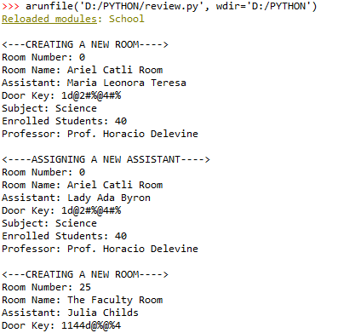

WITH A SUBCLASS:

* The public attributes and methods of the superclass can be directly accessed.
* New attributes and methods can be added with the subclass.
* The public method definitions of the superclass can be called by coding the name of the superclass, the dot operator, and the method name. This will call the version of the method of the superclass.
* Methods of the superclass can be overridden (provided with new definition) by the subclass.

POLYMORPHISM

Polymorphism – lets objects of different types be treated as if they were the same type by referring to a superclass that’s common to the objects.

* REMEMBER: The version of the object’s method will be called.

CHECKING AN OBJECT’S TYPE

* Use the built-in function, *isinstance()* to check the if the object is an instance of a class. Format isinstance(object, [module.]ClassName).

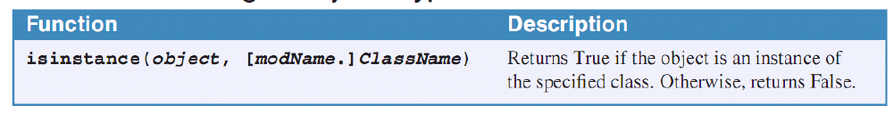

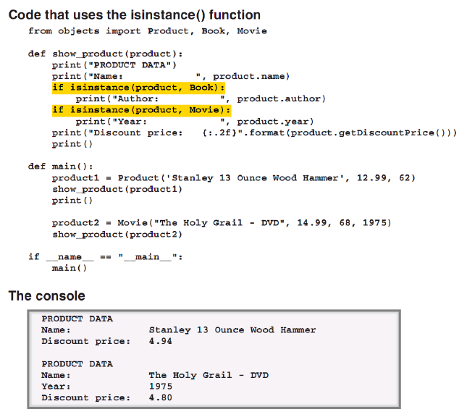

OVERRIDING OBJECT METHODS

* In Python 3 and later, a class named *object* is the superclass for all classes. Every class automatically inherits the object class.
* The methods of the object class are available from any object.

SOME OF THE OBJECT METHODS:

1. __str__() method – returns a string representation of the object.

* When an object is supplied as an argument to the print() function, this method is called for a string representation of the object.

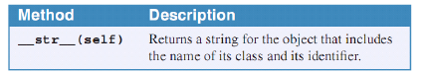

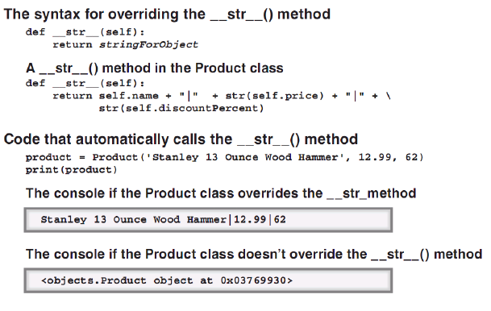

EXAMPLE:

**a. Client file**

from School import *

print("\n<---CREATING A NEW ROOM---->")

science_classroom = Class_room("Ariel Catli Room", 0, 20, "Prof. Horacio Delevine")

science_classroom.assistant = Assistant("Maria Leonora Teresa",science_classroom)

science_classroom.assign_subject(Subject("Science",40))

print(science_classroom)

print("\n<----ASSIGNING A NEW ASSISTANT---->")

science_classroom.assistant = Assistant("Lady Ada Byron",science_classroom)

print(science_classroom)

print("\n<---CREATING A NEW ROOM---->")

faculty_room = Room("The Faculty Room", 25, 30)

faculty_room.assistant = Assistant("Julia Childs", faculty_room)

print(faculty_room)

**b. School module**

# -*- coding: utf-8 -*-

"""

Created on Mon Oct 30 11:05:44 2017

@author: Ariel Domingo Catli

"""

import random

#This is the module

class Room:

def __init__(self, name, number, key_length):

self.name = name

self.number = number

self.door_key = self.__generate_door_key(key_length)

self.assistant = Assistant("N/A", "N/A")

def __str__(self):

return (f"Room Number: {self.number}\n"+

f"Room Name: {self.name}\n"+

f"Assistant: {self.assistant.name}\n"+

f"Door Key: {self.door_key}\n")

def __generate_door_key(self, key_length):

allowed_chars = ['1','2','4','d','#','%','@']

key = ""

for i in range(0,10):

key += random.choice(allowed_chars)

return key

@property

def door_key(self):

return self.__door_key

@door_key.setter

def door_key(self, key):

self.__door_key = key

@property

def number(self):

return self.__number

@number.setter

def number(self, number):

if(number<=1000):

self.__number = number

else:

print("The room number should be equal to or below 1000.")

self.__number = "N/A"

@property

def name(self):

return self.__name

@name.setter

def name(self, name):

self.__name = name

@property

def assistant(self):

return self.__assistant

@assistant.setter

def assistant(self, assistant):

self.__assistant = assistant

class Class_room(Room):

def __init__(self, name, number, key_length, assigned_professor):

Room.__init__(self, name, number, key_length)

self.__assigned_professor = assigned_professor

def assign_subject(self, subject):

self.__subject = subject

def __str__(self):

return (Room.__str__(self))+ f"Subject: {self.__subject.name}\n"

+ f"Enrolled Students: {self.__subject.enrolled}\n"

+ f"Professor: {self.__assigned_professor}\n"

class Assistant:

def __init__(self, name, assigned_room):

self.name = name

self.assigned_room = assigned_room

def assign_room(self, room):

self.room = room

class Subject:

def __init__(self, name, num_enrolled):

self.name = name

self.enrolled = num_enrolled

1. Iterator method – Python automatically calls the __iter__() and the __next__() methods in a for loop to initialize it and to get to the next object in the sequence of objects.

* If an object (container classes) contains multiple objects and a loop is needed to iterate through those objects, override the mentioned methods.

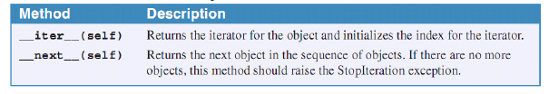

STEPS:

1. Define the __init__() function to have an empty private list of objects.
2. Define the __iter__() function to have a private index and then return the object itself as an iterator that holds the __next_() method.
3. Define the __next__() method that has the checking if the index is within the bounds of the list. If not, raise a StopIteration() exception. Increment the private index variable and then return the item in the list based on the private index.

EXAMPLE:

**a. Client file**

from School import *

print("\n<---CREATING A NEW ROOM---->")

science_classroom = Class_room("Ariel Catli Room", 0, 20, "Prof. Horacio Delevine")

science_classroom.assistant = Assistant("Maria Leonora Teresa",science_classroom)

science_classroom.assign_subject(Subject("Science",40))

print(science_classroom)

print("\n<----ASSIGNING A NEW ASSISTANT---->")

science_classroom.assistant = Assistant("Lady Ada Byron",science_classroom)

print(science_classroom)

print("\n<---CREATING A NEW ROOM---->")

faculty_room = Room("The Faculty Room", 25, 30)

faculty_room.assistant = Assistant("Julia Childs", faculty_room)

print(faculty_room)

print("\n<---ADDING ROOMS TO BUILDING A---->")

building_a = Building()

building_a.add_room(science_classroom)

building_a.add_room(faculty_room)

print("\n<----ROOMS IN BUILDING A--->")

for room in building_a:

print(room)

**b. School module**

# -*- coding: utf-8 -*-

"""

Created on Mon Oct 30 11:05:44 2017

@author: Ariel Domingo Catli

"""

import random

#This is the module

class Building:

def __init__(self):

self.__rooms = []

def __iter__(self):

self.__index = -1

return self

def __next__(self):

if self.__index >= len(self.__rooms)-1:

raise StopIteration()

self.__index += 1

return self.__rooms[self.__index]

def add_room(self, room):

self.__rooms.append(room)

class Room:

def __init__(self, name, number, key_length):

self.name = name

self.number = number

self.door_key = self.__generate_door_key(key_length)

self.assistant = Assistant("N/A", "N/A")

def __str__(self):

return (f"Room Number: {self.number}\n"+

f"Room Name: {self.name}\n"+

f"Assistant: {self.assistant.name}\n"+

f"Door Key: {self.door_key}\n")

def __generate_door_key(self, key_length):

allowed_chars = ['1','2','4','d','#','%','@']

key = ""

for i in range(0,10):

key += random.choice(allowed_chars)

return key

@property

def door_key(self):

return self.__door_key

@door_key.setter

def door_key(self, key):

self.__door_key = key

@property

def number(self):

return self.__number

@number.setter

def number(self, number):

if(number<=1000):

self.__number = number

else:

print("The room number should be equal to or below 1000.")

self.__number = "N/A"

@property

def name(self):

return self.__name

@name.setter

def name(self, name):

self.__name = name

@property

def assistant(self):

return self.__assistant

@assistant.setter

def assistant(self, assistant):

self.__assistant = assistant

class Class_room(Room):

def __init__(self, name, number, key_length, assigned_professor):

Room.__init__(self, name, number, key_length)

self.__assigned_professor = assigned_professor

def assign_subject(self, subject):

self.__subject = subject

def __str__(self):

return (Room.__str__(self))+ f"Subject: {self.__subject.name}\n"

+ f"Enrolled Students: {self.__subject.enrolled}\n"

+ f"Professor: {self.__assigned_professor}\n"

class Assistant:

def __init__(self, name, assigned_room):

self.name = name

self.assigned_room = assigned_room

def assign_room(self, room):

self.room = room

class Subject:

def __init__(self, name, num_enrolled):

self.name = name

self.enrolled = num_enrolled

CUSTOM EXCEPTIONS

* To code custom exceptions, create a subclass of the Exception class.

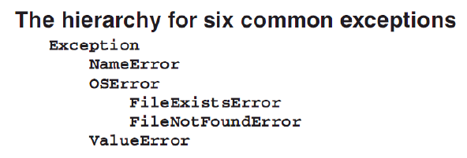

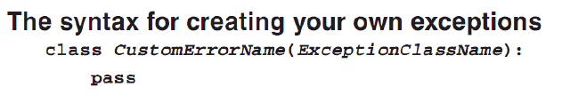

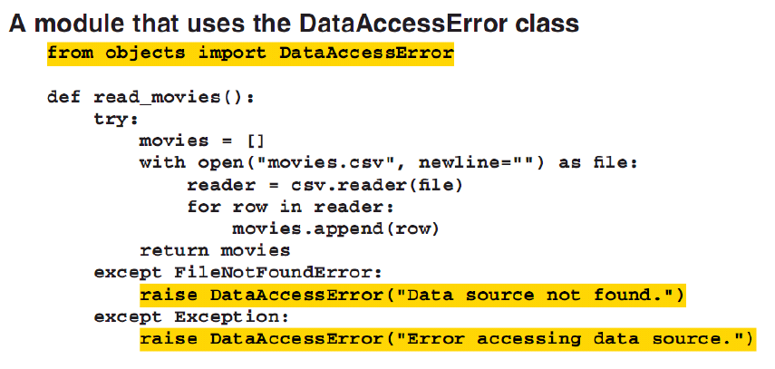

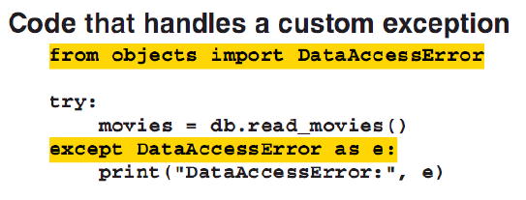

* Use the Exception class in creating the custom exception since it is at the top of the exception hierarchy.

WHEN TO USE INHERITANCE

1. One object is a type of another object. Ex: Room = classroom, faculty_room
2. Both classes are part of the same logical domain. Ex: Room, classroom, and faculty_room are part of the same domain since they are in a school.
3. The subclass primarily adds features to the superclass. Ex: The classroom and the faculty_room adds features to the Room.

Chapter 12. How to Work with Dictionaries

Dictionary – stores a collection of items. Unlike lists that store collection of ordered items, dictionaries store collection of unordered items.

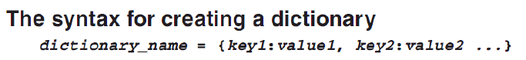

* To create a dictionary, enclose the items in {}. The items are called *key/value pairs*. Format: key:value, example: “CA”:”Canada”.
* A key is usually a string but any other immutable types can be used.
* Unlike lists that can be accessed using index, dictionaries are accessed using the keys.
* Python may reorder the key/value pairs in a dictionary at any time.
* REMEMBER: the pairs can change order.
* In some languages, dictionaries are called *associative arrays*.

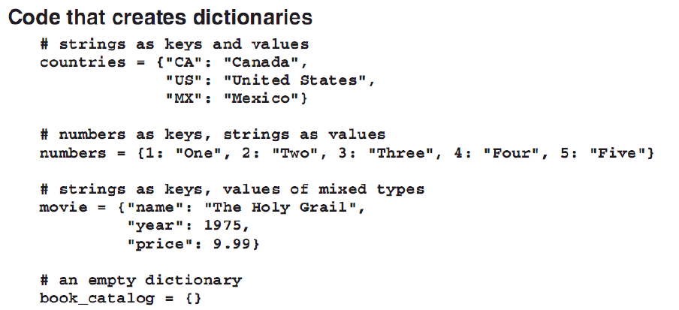

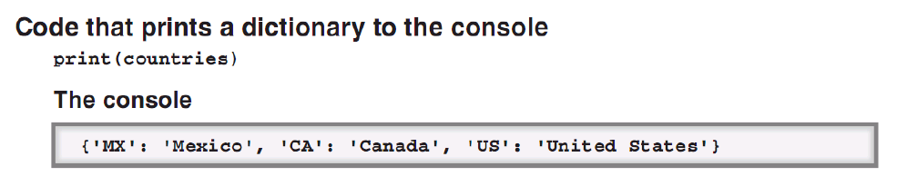

# -*- coding: utf-8 -*-

"""

Created on Mon Nov 6 15:39:31 2017

@author: Ariel Domingo Catli

"""

#creating a dictionary

person = {"name":"Ariel D. Catli", "Age":22, "Address":"774 Real Street, Intramuros, Manila"}

print(person["Address"])

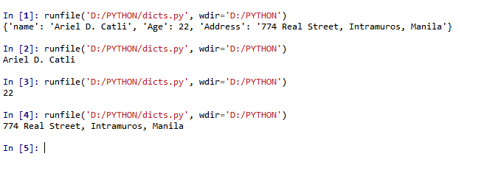

GETTING, SETTING, AND ADDING ITEMS

* To get and item: item_hold = dictionary[“key”]. The item_hold will then contain the value of the “key” if the key exists in the dictionary.
* A KeyError occurs if the key does not exist.
* To set the value of a key in the dictionary: dictionary[“key”] = new_value. The item with the key, “key” will have the value of the new_value.
* If the “key” does not exists, then the pair will be added to the dictionary.

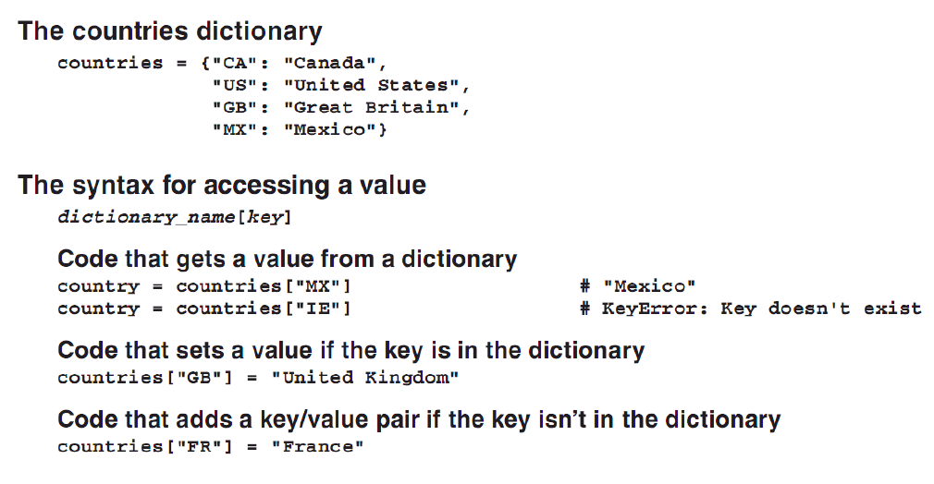

TWO WAYS TO ACCESS A DICTIONARY WITHOUT KEYERROR

1. To prevent a KeyError while accessing a key in the dictionary, use the *in* clause in an *if* clause:

if key in dictionary:

something = dictionary[key]

1. Using the .get() method of a dictionary, a default value can be assigned if the key does not exist.

something = dictionary.get(key [, default_value])

* If the key is not in the dictionary and the default value is specified, then the default value will be returned.
* If the key is not in the dictionary and the default value is not specified, *None* will be returned.

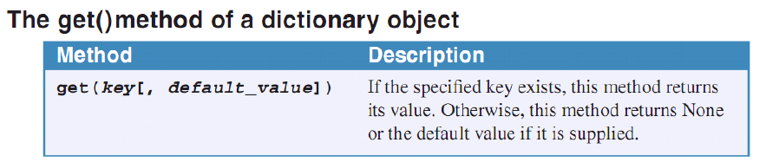

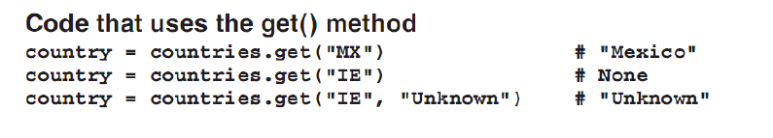

DELETING ITEMS

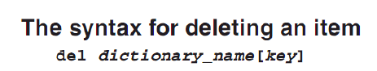

* If the key is not found, then a KeyError is raised.
* Check with the *in* and *if* clauses first before deleting.
* Use the dictionary.pop() method to delete an item. It returns the value for the key and deletes the item in the dictionary. A default value can also be provided.
* If the key does not exist, then KeyError is raised.

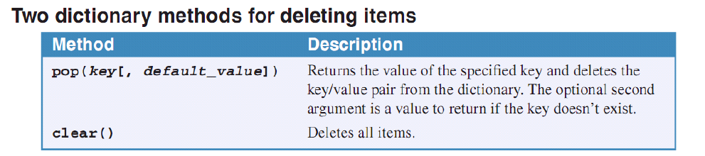

* The .clear() method clears all the items in the dictionary.

# -*- coding: utf-8 -*-

"""

Created on Mon Nov 6 15:39:31 2017

@author: Ariel Domingo Catli

"""

#creating a dictionary

person = {"Name":"Ariel D. Catli", "Age":22, "Address":"774 Real Street, Intramuros, Manila"}

print(person)

person["Name"] = "Joshua Viterbo"

person["Age"] = "23"

print(person)

if "Gender" in person:

print(person["Gender"])

else:

print("Gender is not specified")

gender = person.get("Gender")

print(gender)

gender = person.get("Gender", "N/A")

print(gender)

person["Gender"] = "Male"

print(person)

print(person.pop("Gender"))

print(person)

person.clear()

print(person)

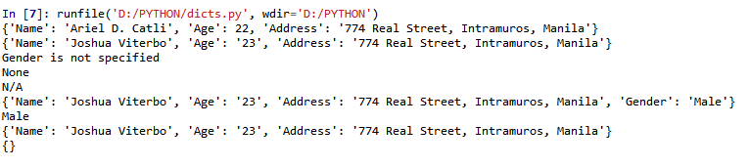

LOOPING THROUGH KEYS AND VALUES

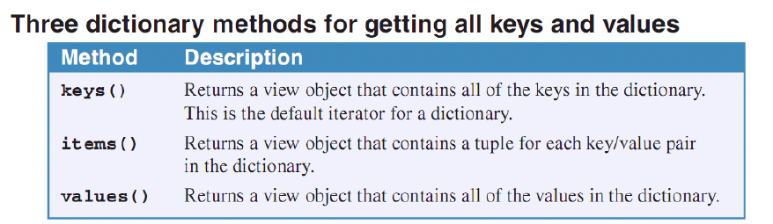

* All of the methods above return a *view object* that contains the keys or values of the dictionary.
* A view object is an iterator. A loop can be used to iterate over the values contained in the object.
* A view object is also linked to the dictionary. If the items in the dictionary are modified, Python automatically updates the view object.
* Default iterator contains keys. Therefore: for key in dictionary: (key will have one key).
* The key() methods returns a view object of the keys in the dictionary. Use the for loop to iterate on the keys. Format for key in dictionary.keys():
* To loop through all keys and values, use the items() method. This method returns a view object that contains a tuple for each item. Format: for key, value in dictionary:
* REMEMBER: The returned view object from the .items() method must be unpacked since it is a tuple.
* To loop through values, use the values() method. It returns a view object of the values inside the dictionary.
* REMEMBER: Items in a dictionary are unordered. To sort, convert the dictionary to list first.

HOW TO CONVERT BETWEEN LISTS AND DICTIONARIES

* To convert the view object from the dictionary, use the list(view object) method. A list is the result of the statement. A list of the values and the keys can be made.
* When the list() method is used with the dictionary.items(), a list of tuples is made.
* When the list() method is used with the dictionary.values(), a list of values is created.
* When the list() method is used with the dictionary.keys(), a list of keys is made.

# -*- coding: utf-8 -*-

"""

Created on Mon Nov 6 15:39:31 2017

@author: Ariel Domingo Catli

"""

#creating a dictionary

person = {"Name":"Ariel D. Catli", "Age":22, "Address":"774 Real Street, Intramuros, Manila"}

print(person)

listing = list(person.items())

print(listing)

listing = list(person.values())

print(listing)

listing = list(person.keys())

print(listing)

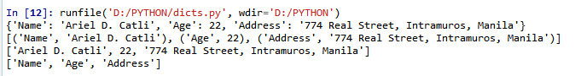

* To convert a list of key/value pairs to a dictionary, use the dict(list) method.
* The format of the list should be: [[key1,value1],[key2,value2],[key3,value3], … ,[keyN,valueN]].

# -*- coding: utf-8 -*-

"""

Created on Mon Nov 6 15:39:31 2017

@author: Ariel Domingo Catli

"""

#creating a dictionary

person = {"Name":"Ariel D. Catli", "Age":22, "Address":"774 Real Street, Intramuros, Manila"}

print(person)

listing = [["Name", "Joshua Viterbo"], ["Age",23]]

print(listing)

dictionary = dict(listing)

print(dictionary)

print(listing)

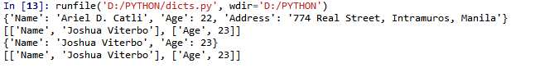

COMPLEX DICTIONARIES

* Dictionaries can be nested like the lists of lists.
* Multiple keys can be used in dictionaries. To access: dictionary[“keyA”][“keyB”]
* REMEMBER: The value of a key can be a list, tuple, or even a dictionary.
* Use compounding referencing when getting deeper in a dictionary.

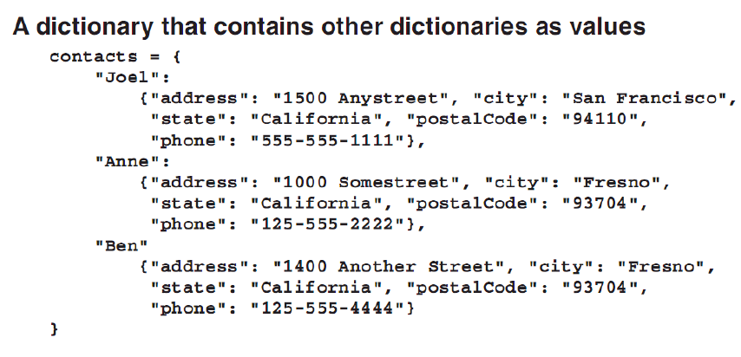

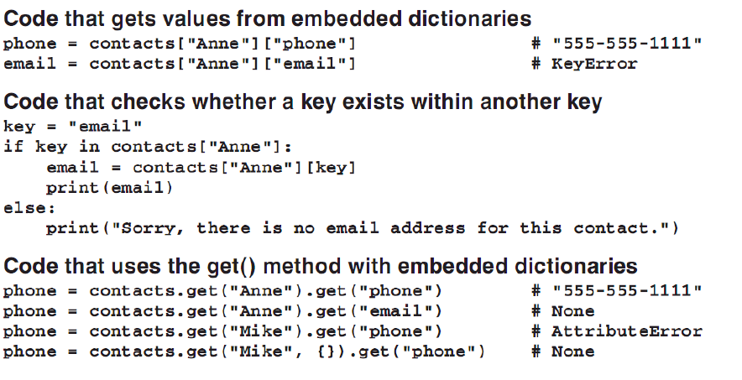

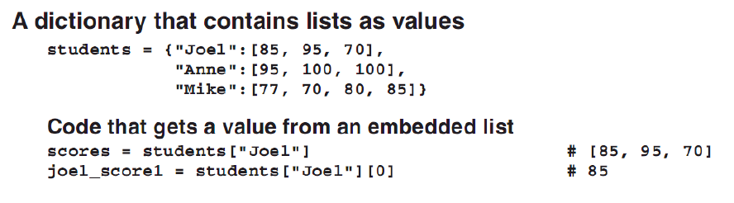

* TIP: Use an empty dictionary as a default value in case there is a deeper access with a dictionary.

Chapter 16. How to Design an Object-Oriented Program

TECHNIQUES FOR OBJECT-ORIENTED DESIGN

* In many cases, the model for an object-oriented program can be based on an existing real-world system.

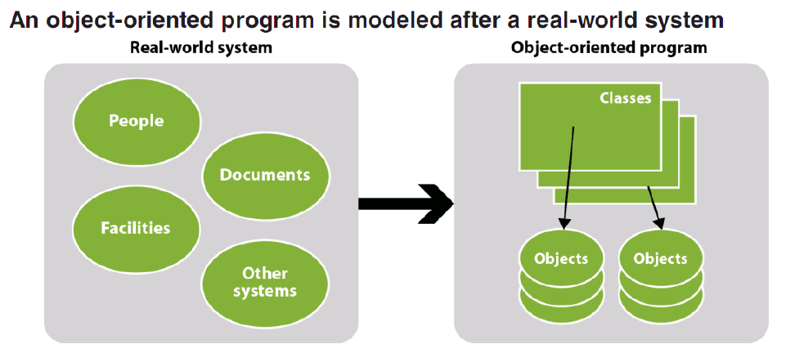

* Each class represents one object, or *entity*, in the real-world system.
* Each object instantiated from a class represents one instance of the entity.
* Each attribute of the object stores one item of information about the entity.

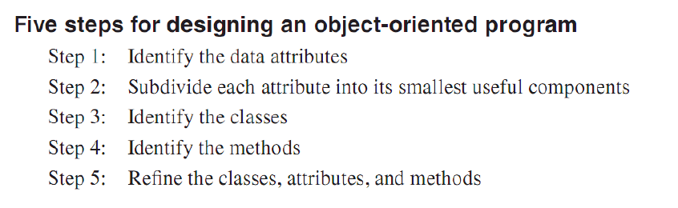

VERSION:

1. Identify the entities.
2. Identify the relationships.
3. Identify the attributes needed.
4. Structure the flow of the process.
5. Identify the needed operations.
6. Refine.

THREE-TIER ARCHITECTURE

Multi-tier program architecture – classes that perform different functions of the program are separated into two or more layers or *tiers*.

Three-tier architecture – mostly contain presentation, business, and a database tier.

1. Presentation tier – handles the details of the program’s user interface. The code for the presentation tier is typically stored in a class that defines the objects needed to display the user interface.
2. Database tier – stores the code that provides data access that’s required by the program. Typically, this requires retrieving, adding, updating, and deleting data. This tier also works with files and other data sources other than a database.

Object-Relational Mapping, O/R Mapping, ORM – code that converts a row in the relational database to an object or vice versa.

1. Business tier – provides an interface between the database tier and the presentation tier. This tier often includes classes that correspond to business entities such as products and customers. It may also include classes the implements business rules, such as discount or credit policies. The classes in this tier are called *business classes* and the objects are called *business objects*.

ADVANTAGES:

* A tier can be swapped without harming the other tiers.
* Division of work among developers is based on tiers.
* Code reuse.

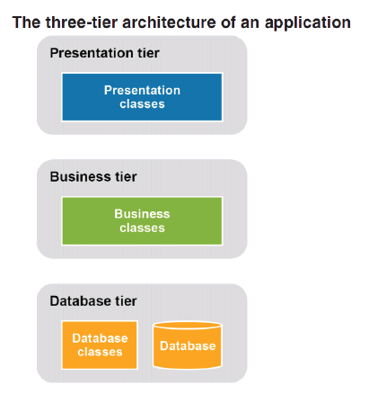

Chapter 18. How to Build a GUI Program

* A toolkit makes it easier to create a GUI program in Python.
* One of the most common GUI toolkit used in Python is *tkinter*.
* A GUI begins with a component that’s typically called *root window*.
* The buttons, labels, and text entry fields are called *components* or *widgets*.

STEPS IN CREATING A GUI

1. Import the tkinter module, preferably into a shorter namespace like *tk*.
2. Set a variable to hold the object made by the *tk.Tk()* statement, preferably named *root*.
3. Set the properties of *root*.
4. After all properties are set, call the *root.mainloop()* statement. It cause the program to enter an *event processing loop* that listens for *events* such as the user clicking a button.
   1. If the *mainloop()* is not called, the window will just execute the rest of the program and then exits.
   2. REMEMBER: all code that set up the window must be defined first before calling the *mainloop()*.

SOME WINDOW PROPERTIES

* Tk() – creates a Tk object that defines the root window.
* title(title) – sets the title of the window from the *title* string.
* geometry(“widthxheight”) – sets the dimensions of the root window. Provide it with string containing the width and the height separated by ‘x’.
* mainloop() – makes the root window visible and starts an event processing loop that allows the program to handle events that occur in the window. NOTE: call this method after all properties of the window are set.

# -*- coding: utf-8 -*-

"""

Created on Sat Feb 3 21:23:01 2018

@author: Ariel Domingo Catli

"""

#GUI exercise

import tkinter as tk

root = tk.Tk()

root.title("My first GUI program in Python")

root.geometry("300x200")

root.mainloop()

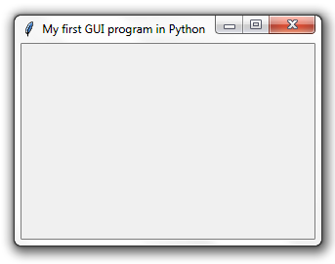

WORKING WITH FRAMES AND BUTTONS

Frames – invisible container that is used to group components.

Steps in working with frames and buttons:

1. Import the *ttk* module from the *tk* module.
2. Create a frame using the Frame() function. Format: frame_var = ttk.Frame(parent [,padding])
   1. parent – the parent element. Ex. Root
   2. padding – padding between parent and the frame.
3. Call the pack method of the frame object to display the frame or element. Format: frame_var.pack([fill][, expand])
   1. fill – when set to tk.BOTH, the component automatically resize itself vertically and horizontally to fill the parent component.
   2. expand – set to true to expand to fill.
4. To create a button, use the ttk.Button() method. Format: button_x = ttk.Button(parent, text=”button text”)
5. Call the element’s pack() method. Format: button_x.pack(). Same arguments with the frame.

HANDLING A BUTTON CLICK EVENT

* Events must be handled for a GUI program.
* The event must be connected to a *callback function* or an *event handler*.
* To connect a button to a click event handler, use the *command* argument. Format: button1 = ttk.Button(parent, text=”button text” command=event_handler_function)

NOTE: the event handler functions must be defined above the code for the button.

* The root.destroy() method closes the root window.
* It can also be called as a value to the command argument but most of the time, there are pre-destroy tasks to be done that’s why there should be an event handler function for destroying windows.

# -*- coding: utf-8 -*-

"""

Created on Sat Feb 3 21:23:01 2018

@author: Ariel Domingo Catli

"""

#GUI exercise

import tkinter as tk

from tkinter import ttk

def btn1_click():

root.title("Changing the title")

def btn2_click():

root.destroy()

root = tk.Tk()

root.title("My first GUI program in Python")

root.geometry("300x200")

frame = ttk.Frame(root, padding="10 50 30 40")

frame.pack()

button1 = ttk.Button(frame, text="Ok", command=btn1_click)

button1.pack(fill=tk.BOTH, expand = True)

button2 = ttk.Button(frame, text="Cancel", comman=btn2_click)

button2.pack()

root.mainloop()

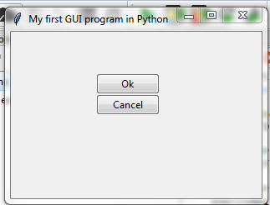

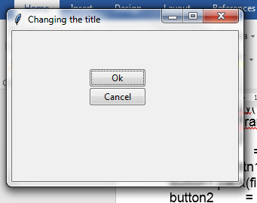

WORKING WITH LABELS AND TEXT ENTRY FIELDS

Labels – label components

* To create a label, use the ttk.Label() function. Format: label1 = ttk.Label(parent, text=”label text”)
  + These components are assigned to variables so that their properties can be changed during the run of the program.
  + If the components will not be changed all throughout the duration of the program, just use the ttk.component(parent, text=”component text”).pack() style.
  + Labels are mostly done like the second style.

# -*- coding: utf-8 -*-

"""

Created on Sat Feb 3 21:23:01 2018

@author: Ariel Domingo Catli

"""

#GUI exercise

import tkinter as tk

from tkinter import ttk

def btn1_click():

root.title("Changing the title")

def btn2_click():

root.destroy()

root = tk.Tk()

root.title("My first GUI program in Python")

root.geometry("300x200")

frame = ttk.Frame(root, padding="10 50 30 40")

frame.pack()

ttk.Label(frame, text="This is the first button").pack()

button1 = ttk.Button(frame, text="Ok", command=btn1_click)

button1.pack(fill=tk.BOTH, expand = True)

ttk.Label(frame, text="This is the last button").pack()

button2 = ttk.Button(frame, text="Cancel", comman=btn2_click)

button2.pack()

root.mainloop()

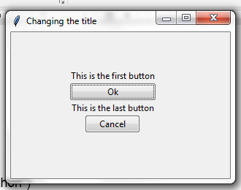

Text Entry Field – a component that allows the user to input text (also known as textbox, text field, or entry field).

HOW TO USE A TEXT ENTRY WIDGET

1. Set a tk.StringVar() object that will hold the text of the textbox. This is different to the data that the textbox will hold. Use this object to set the data. It’s like an interface to the text of the textbox.
2. Create an Entry widget using ttk.Entry(). Format: tbox1 = ttk.Entry(parent, width, textVar[, state])
   1. parent – the parent element
   2. width – visual length of the Entry object
   3. textVar – the binding StringVar object
   4. state – set to “readonly” if the textbox is a read-only component
3. Using the StringVar bound to the textbox, use the get() and the set() functions to get and set the text in the textbox.
   1. Format: stringVarObj.set(something)
   2. Formta: something = stringVarObj.get()